1. Preface

This Guide explains how to use the system to process collection orders. It assumes that you are familiar with the basic principles of trade finance relating to collection orders, and with web browsers.

# About Collection Orders

Trade Innovation handles four basic kinds of collection order:

* Inward clean collection orders
* Outward clean collection orders
* Inward documentary collection orders
* Outward documentary collection orders

For clean collection orders, only the financial documents are routed via the banks. The commercial documents (for example bills of lading or insurance certificates) are despatched to the importer by the exporter. The remitting bank may include instructions for a number of different payments from the importer relating to different commercial transactions in the same collection order, provided they are all in the same currency.

Clean collection orders may also be used where no goods are involved (for example for payments for services) and for inland collection orders where the remitting bank and the collecting bank are in the same country.

For documentary collections, both the financial and the commercial documents are routed via the banks. The collection order must record the list of accompanying documents, and therefore the collection order will be limited to a single commercial transaction.

Within the processing for these basic kinds of collection order, the system includes facilities to allow you to handle:

* D/P (documents against payment) collections
* D/A (documents against acceptance) collections
* Collections pour aval (documents against acceptance pour aval)
* Collections that mix D/P, pour aval, and D/A instructions
* Direct collections, where the exporter creates the collection order and sends it directly to the collecting bank, with a copy to the remitting bank. The system supports the block allocation of reference numbers to the remitting bank's customers for this purpose
* Inland collections, where the remitting bank and collecting bank are in the same country. These are handled in the system as clean collection orders

Inward and outward collection orders can also be categorised into product types Your bank can choose what product types, if any, to set up. Product types could be used to distinguish between inland and overseas collection orders, for example.

If your bank has set up product types, you will be able to specify what type a collection order belongs to when you create it, and you can use product types to filter which collection orders you see.

## Payments

Collection orders can include details of up to ten drafts to reflect multiple payments for a single transaction or, for clean collection orders, single drafts for separate transactions. Each payment can be acknowledged (see page 26), accepted and paid (see page 41) separately.

For inward collection orders, your bank can configure the system so that a payment action is automatically created in the diary:

* For each draft your bank has accepted pour avail
* For each accepted draft where your bank holds the draft

Further, such actions can be configured so that overnight processing uses them to create a Payment event automatically during overnight processing when settlement becomes due.

## Payments to Third Parties

The system includes facilities to allow you to record payments to be made to third parties and to enter details of those payments as they are made.

## Non-acceptance and Non-payment

The system allows you to produce or record advices of non-acceptance and non-payment against individual drafts on a collection order. These are handled using SWIFT MT416 messages.

Payments flagged as not accepted cannot be accepted in a subsequent event. Payments flagged as not paid cannot be paid or accepted in subsequent events. However, the status of a payment can be changed using an Adjust event.

## Documents and Parties

The system is delivered with a list of standard financial and commercial documents that may accompany a documentary collection order, and a list of the standard parties to a transaction. These lists facilitate data entry when creating a collection order. The system facilities allow you to maintain these lists both as part of static data maintenance and when entering details of a collection order.

## Financing and Discounting

If you have the financing module implemented you can use it to enter advances against collection orders. The module permits you to enter loans from within:

* The Create event for outward collection orders
* The Payment event for inward collection orders
* The Discount Acceptance event for accepted drafts

For collection orders involves multiple payments, you can enter separate financing transactions against each accepted draft.

Loans can have interest charged in advance or in arrears, or they can be discounted.

The financing module also allows you to create financing transactions from within an outward collection order using a Finance Existing Collection event, or independent of any existing trade finance transaction. Trade finance transactions of the latter type can then be associated with the financing transaction as it is created.

For a full description of the financing module's functionality see the 33TFinancing User Guide 33T40T– Trade Innovation.

## Credit Risk Management

If your bank has implemented a credit risk management application, your system will perform on-line credit limit checking as necessary as part of the life-cycle of a transaction. Depending on how your system has been configured, account manager approval for a credit line utilisation may be required always, or only when overline conditions are detected.

See the Common Facilities User Guide – Trade Innovation for more information on credit risk management.

## Licenses

The system includes facilities for the use of licenses with transactions of the type described in this guide. Your bank can also make returns to the central licensing authority on a regular basis to show the utilisation of the licenses issued to customers.

One or more licenses can be linked to a transaction and a reservation made for the amount of the transaction. When a claim is received, a drawdown can be made against the license. Full validation between the transaction and license is provided to ensure that licenses do not become overdrawn.

If the amount of the transaction is increased or decreased during an amendment event, then additional reservations can be made for an increase or the balance reinstated for a decrease. Any unutilised balance on expiry or cancellation can be (optionally) reinstated on the license.

See the Licenses User Guide – Trade Innovation for details of licenses.

If the SuppressLicenseAtCollectionCreation system option has been set, then the License Pane will be disabled during the Create, Amend and Adjust events but you can still link to and drawdown against a license at the time of payment.

## Shipping Guarantees

The system includes facilities which allow your bank to issue guarantees against an inward documentary collection order in situations where goods arrive before the relevant document of title.

Shipping guarantees are created as standalone transactions which are then linked to the inward documentary collection order when the document of title arrives.

You can issue any number of shipping guarantees against an inward documentary collection order.

When the document of title is recorded against the transaction, the inward documentary collection order Create event can be used to link a shipping guarantee with the document of title in lieu of which it was issued; and a document requesting the return of the actual shipping guarantee may be issued. Shipping guarantees can also be linked to an inward documentary collection order during Amend events and Adjust events.

For full information on shipping guarantees see the Shipping Guarantees User Guide – Trade Innovation.

## Using Trade Innovation to Process Collection Orders

Much of the information required to process a collection order is the same, regardless of what type of collection order it is or whether it is inward or outward. The system therefore treats all collection orders as belonging to one of the four basic types:

* Inward clean collection orders
* Outward clean collection orders
* Inward documentary collection orders
* Outward documentary collection orders

When you create a new collection order, select which of the four types the order will be. The system uses the same set of events and associated input windows to process each type of collection order, with minor variations to reflect the different information needed for each of the different types of collection order and the differences in processing between inward and outward collection orders.

The table below list the events covered in this guide, explaining what each event allows you to do. The table lists the names given to events when the system is delivered. Your bank can change these names once the system is installed. Consequently, the names in your version of the system may be different from the ones listed here.

There are two names for each event:

* The full name, which is displayed when you choose a new event
* The short name, which is displayed in the Work in Progress pane of the Master Summary window

This guide uses the full name of each event, as delivered with the system.

In addition to the events listed in the table, you can also use the functionality described in the Common Facilities User Guide – Trade Innovation when processing transactions in the system.

|  |  |  |
| --- | --- | --- |
| Full Name | Short Name | What it Does |
| Accept | Accept | Allows you to create or receive an acceptance of a collection order or of an individual payment on a collection order. |
| Adjust Collection | Adjust | Allows you to amend the complete details of a collection order (see page 38). |
| Advance | Advance | Allows you to enter details of a loan to the exporter against an outward collection order. See Chapter 7. |
| Amend Collection | Amend | Allows you to amend certain details of the collection order, and also to expire the collection order (see page 35). |
| Continue Payment | Cont Pay | Allows you to continue processing a payment after waiting for the customer's acceptance of a finance offer (see page 4). |
| Create | Create | Allows you to create an inward or outward collection order, including for outward collection orders the option to finance the exporter (see page 8). |
| Discount Acceptance | Discount | Allows you to discount an accepted draft (see page 62). |
| Finance Existing Collection | Finance | Available only if your system has the financing module implemented. Allows you to create a financing transaction from within an outward collection order. See the Financing User Guide – Trade Innovation. |
| NonAcc/Pay | Non Acceptance/Payment | Allows you to create or receive an advice or non-acceptance or non-payment for one or more drafts on a collection order. |
| Receive Documents | Rec Doc | Available only if your system has the shipping guarantees functionality implemented. Allows you to record the receipt of a document of title against an inward documentary collection order - see the Shipping Guarantees User Guide Trade Innovation. |
| Payment | Payment | Allows you to receive and make payment for a collection order or for an individual payment (see page 46). |
| Receive Acknowledgement | Rec Ack | Allows you to enter details you have received of an acknowledgement of a collection order or of an individual payment on a collection order (see page 26). |
| Repay Advance | Repay Adv | Allows you to record full or partial repayment of a loan to the exporter (see page 58). |

# Creating a Collection Order

The system uses the same Create event to enter details of a collection order, regardless of the type of collection order and regardless of whether your bank is the remitting bank, the collecting bank or the presenting bank.

As remitting bank, you will use the functionality described in this chapter to enter details of a collection order, as received from the drawer, and to send details of the collection order to the collecting bank (except for a direct collection order).

As collecting bank, you will use the functionality described in this chapter to enter details received from the remitting bank or, in the case of a direct collection order, from the drawer. You may also use the system to send details of the collection order to the presenting bank.

As presenting bank, you will use the functionality described in this chapter to enter details of a collection order received from the collecting bank.

## Direct Collection Orders

The system permits your bank to allocate blocks of numbers to its customers for use in creating direct collection orders. Whenever you create a new direct collection order for which the drawer is a customer of your bank, enter the reference number provided to you by the drawer into the Enter Pre-allocated Reference field in the Create New Master window. The system will check the reference number provided to ensure that it has been allocated to that customer and has not yet been used.

## Exporter Loans

For outward collection orders, the system allows you to enter details of a loan made to the drawer against the collection order at the same time as you enter details of the collection order itself.

When you enter details of a loan as part of the Create event, the system treats the details as part of the Create event and validates them and, if required, performs any review step on them together with the Create event data.

See Chapter 7 for further information on entering details of a loan to the drawer. Alternatively, if you have the financing module implemented see the Financing User Guide – Trade Innovation.

## Licenses

If a license is required, then you must link a license to the collection order and make a reservation to cover the amount of the collection order (providing that your system is set up to link licenses when creating the collection order). There will be some additional validation when creating the collection order. For example:

* The date that the collection order was received must not be before the license Valid From date
* The Expected Date of shipment must be between the license Valid From and Valid To dates
* The amount and currency of the collection order will be validated against the license
* The name of the drawer or drawee must be the same as the nominated party on the license
* The Goods Code must match that on the license
* If a product type is entered, then it must be one that is allowed by the license

See the Licenses User Guide – Trade Innovation for more details.

## Shipping Guarantees

If your system has the shipping guarantees functionality implemented, then for inward documentary collection orders you will be able to link the collection order to one or more shipping guarantees from within the Create event. See the Shipping Guarantees User Guide – Trade Innovation for instructions.

As the Create event is released, a Link Document of Title event is created against each of the relevant shipping guarantees. If a shipping guarantee is removed from a transaction in a subsequent event, an Unlink Document of Title event is created against that shipping guarantee. These events allow your bank to maintain an audit history of the use of shipping guarantees.

## Using Deal Templates to Create a New Collection Order

Trade Innovation permits you to create deals (transactions) from templates and/or, if you have the capability ManageDealTemplates assigned, to add, update and delete deal templates.

You can create a new collection order from a template at one of three points:

* From within the TI Dashboard. In the New Master pane, the Create from Template button allows you to select the template to use. You must specify the Team, the Branch and the Product
* From within the Master Browser window. In the New Master pane, the Create from Template button allows you to select the template to use. You must specify the Team, the Branch and the Product
* From within a transaction, during the Input step of an event that is creating a new master record. The Create from Template link allows you to select the template to use

See the *Common Facilities Guide* – Trade Innovation for further details.

## Creating a New Collection Order

To create a new collection order, in the Masters window, select the Team and Behalf of branch and use the drop-down list in the New Masters pane to select the appropriate collection order product then click **New**. The system creates a Create event at either a Log step or Input step (see page 13), depending on how the Workflow orchestration controlling the event is configured. See the *Workflow Tailoring User Guide* – Trade Innovation for details.

Logging a Collection Order

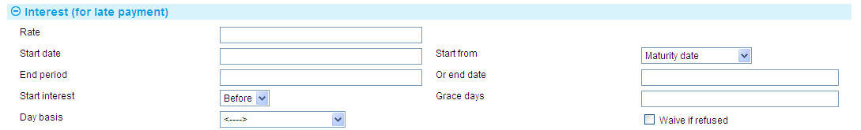

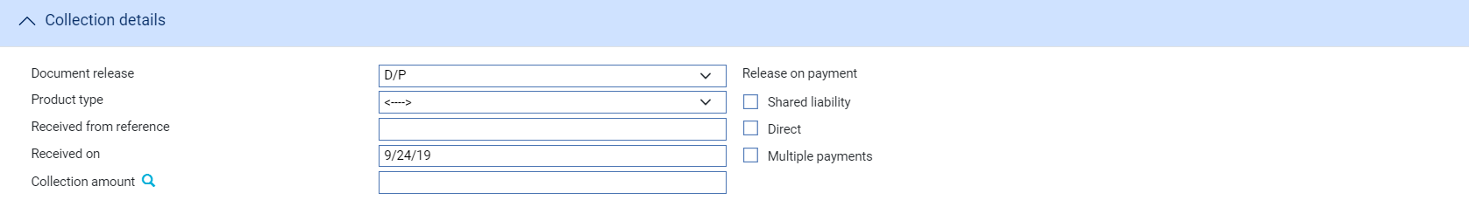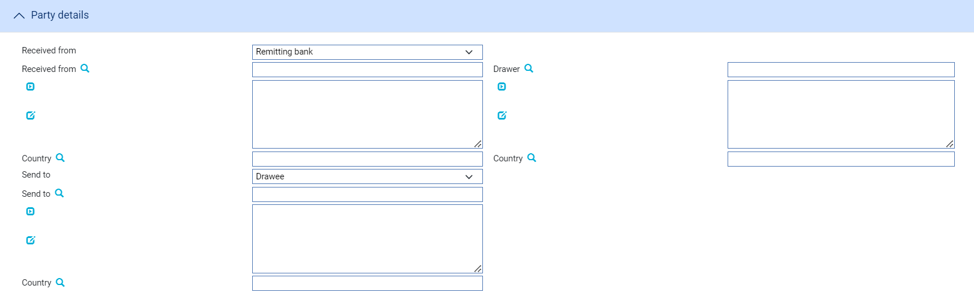

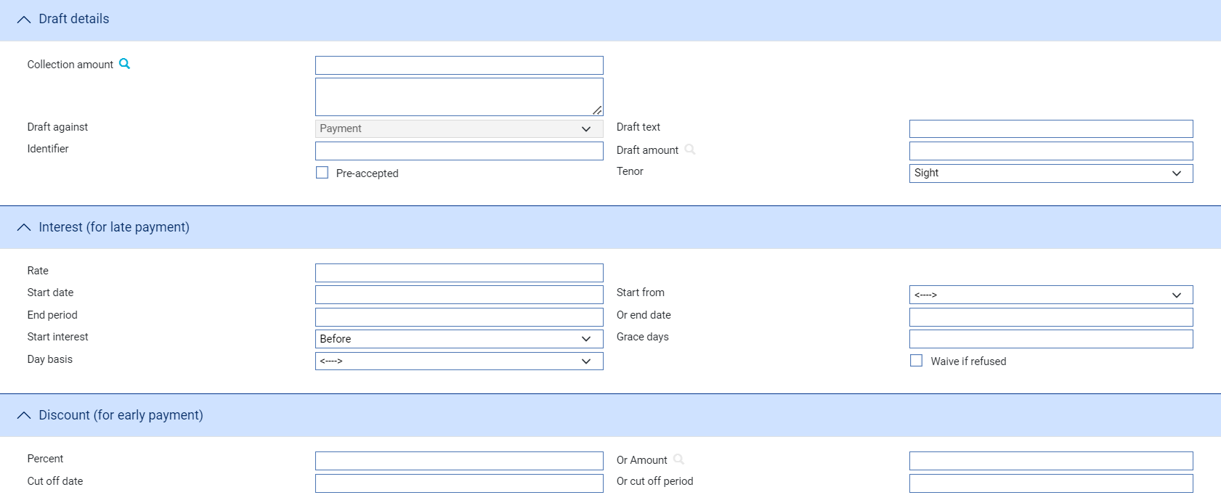

A Log step uses the following panes. Depending on how your system is configured, panes and fields available in log steps can be tailored for each data capture step. See the *SDK - Screen Tailoring Guide* – Trade Innovation for details:

* The Collection Details Pane (see page 15)
* The Parties Pane (see page 16)
* The Draft Details Pane (see page 17) (including interest for late payment and discount for early payment)

### The Collection Details Pane

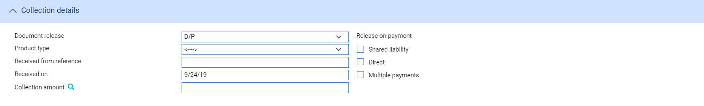

The following table explains what to enter into the fields in the Collection Details pane:

|  |  |
| --- | --- |
| Field | What to Enter |
| Document Release | Specify the condition on which the financial or commercial documents accompanying the collection order are to be released. Select from one of the following:   * D/P (release documents against payment) * D/A (release documents against acceptance) * Pour Aval * Other   If you specify 'Other', the system creates an additional field in which you can specify some other condition. |
| Product Type | If your bank has set up product types for collection orders, select the appropriate one from the drop-down list in this field. |
| Received From Reference | The reference given to the collection order by the party from which you received it.  The value you enter here is compared to the Issuer's Reference for any collection order within the same product on your database. If the system finds a duplicate reference, it issues a warning message. |
| Received On | The date on which the collection order was received. This defaults to today's date. |
| Collection Amount | The total amount of the collection order. |
| Shared Liability | Check this box if any liability for the collection order is to be shared with a third party, such as an export credit guarantor. |
| Direct | Check this box if this is a direct collection order. |
| We Will Avalise | Displayed if you specify 'Pour Aval' or 'Other' in the Document Release field. Check this box if your bank intends to avalise drafts on the collection order, otherwise leave the check box blank. |
| Multiple Payments | Check this box if the collection order is to allow multiple payments. When you click **Refresh** an additional pane - the Payment pane - is displayed which allows you to enter details of each draft in turn. |
| Finance Requested | For an outward collection order, check this box if the exporter has requested an advance or negotiation payment. |

### The Parties Pane

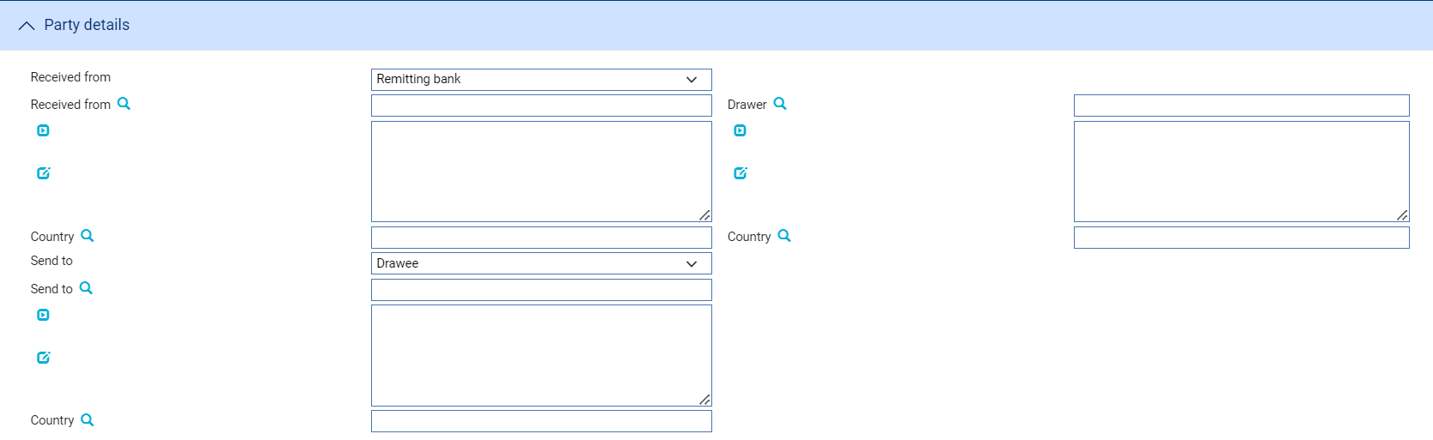

The following table explains what to enter into the fields in the Parties pane:

|  |  |
| --- | --- |
| Field | What to Enter |
| Received From | The party from whom your bank received the collection order details. The drop-down list displays the standard list of parties for your system. |
| Country | The Received From party's country. |
| Drawer | The Drawer fields are displayed only if you do not specify the drawer in the Received From field.  During an Input step this field is mandatory if you have not specified the drawer in the Received From field. |
| Country | The drawer's country. |
| Send To | The party to whom the collection order is to be sent. The drop-down list displays the standard list of parties for your system. |
| Country | The Send To party's country. |
| Drawee/Country | These fields are displayed only if you do not specify the drawee in the Send To field. Use them to identify the drawee and their country. |

### The Draft Details Pane

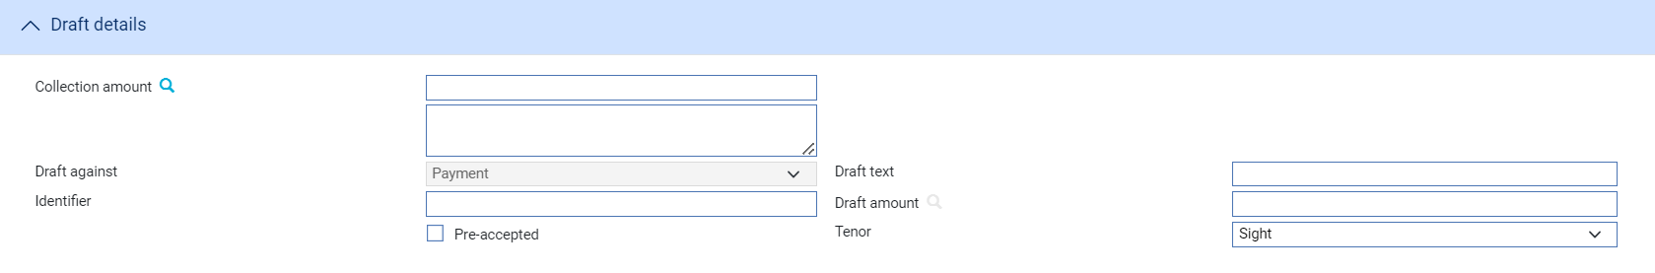

The Draft Details pane displays details of the draft or drafts associated with the collection order. By default, the system assumes a single draft, and by default displays the value of the full collection order in the Amount field, and uses 'Sight' as the tenor.

If you check the Multiple Payments field, the pane changes pane to allow you to define each draft in turn.

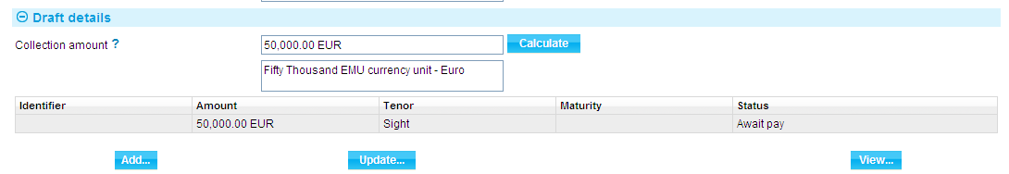

Click **Add**.

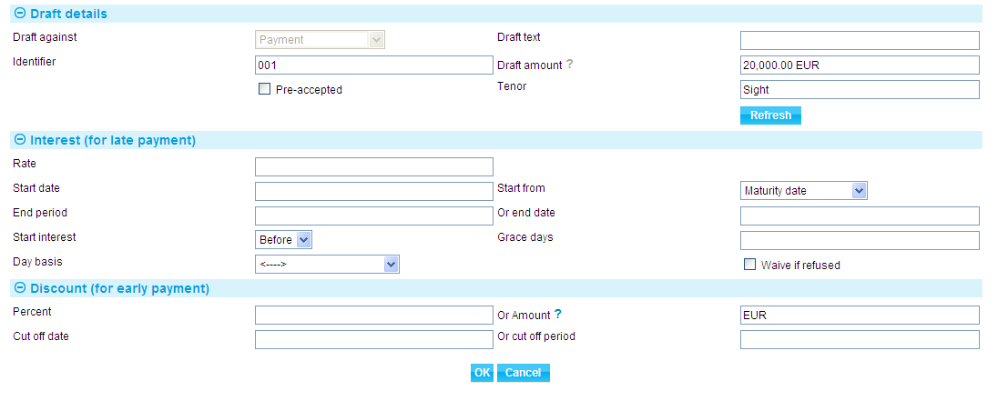

In the window that appears amend the amount and any other draft details - the following table explains what to enter into the fields in this window. Click **OK** to close the window when you have completed input.

|  | Field | What to Enter |
| --- | --- | --- |
|  | Draft Against | The value selected in this field can be changed only if you have specified 'Other' in the Document Release field.  Indicate whether documents relating to this draft are to be released against payment, acceptance or acceptance pour aval. By default, the system uses the value entered against the Document Release field. |
|  | Draft Text | Free format text identifying the document against which the payment is to be made. |
|  | Identifier | An identifier for the payment, such as a draft number, to differentiate it from other payments associated with the collection order. |
|  | Draft Amount | The amount of the payment in the collection order currency. |
|  | Pre-accepted | This box is only displayed if the Draft Against field is set to Payment. Use it to specify whether or not a draft against payment has been accepted before the bank receives it. By default the box is blank, indicating that the draft has not been pre-accepted. Click once on the box, so that it is checked, if the draft is pre-accepted.  If this field is checked, the Tenor field is replaced by a Maturity Date field in which you can enter a maturity date for the pre-accepted draft. |
|  | Tenor | Select the tenor of the draft. |
|  | Rate | The interest rate to use to calculate late payment interest. |
|  | Start Date/Start From | Either enter an actual date at which interest will begin to be charged into the Start Date field, or select a trigger date, such as' Arrival of Goods', using the Start From field.  By default, the system uses the maturity date of the payment, displayed in the Start Date field, as the date interest begins to be charged. |
|  | End Period/Or End Date | Specify the point at which the system should cease charging interest, either as a date, or as a text instruction (for example, 'until arrival of proceeds'). |
|  | Start Interest | Enter a number into the Grace Days field to specify a days grace period following the start date, before the system begins to charge interest. If you do, you can also specify whether interest is to be charged for the whole overdue period (Before), or just from the end of the days grace period (After). |
|  | Days Basis | The system will use as a default the interest days basis associated with the collection order currency. You can override this by selecting one of the values from the drop-down list. These values are listed in the Common Facilities User Guide – Trade Innovation. |
|  | Waive if Refused | Indicate whether interest is to be waived if refused or not. By default, the box is checked, indicating that interest is to be waived if refused. Click once on the box, so that it becomes blank, if interest is not to be waived if refused. |
|  | Percent/Or Amount | Define the discount either as a percentage or as an amount. |
|  | Cut Off Date/Or Cut Off Period | The date until which the discount will be given. You can specify an actual date, or enter text, for example 'Maturity date'. |

### Entering Full Details of the Collection Order

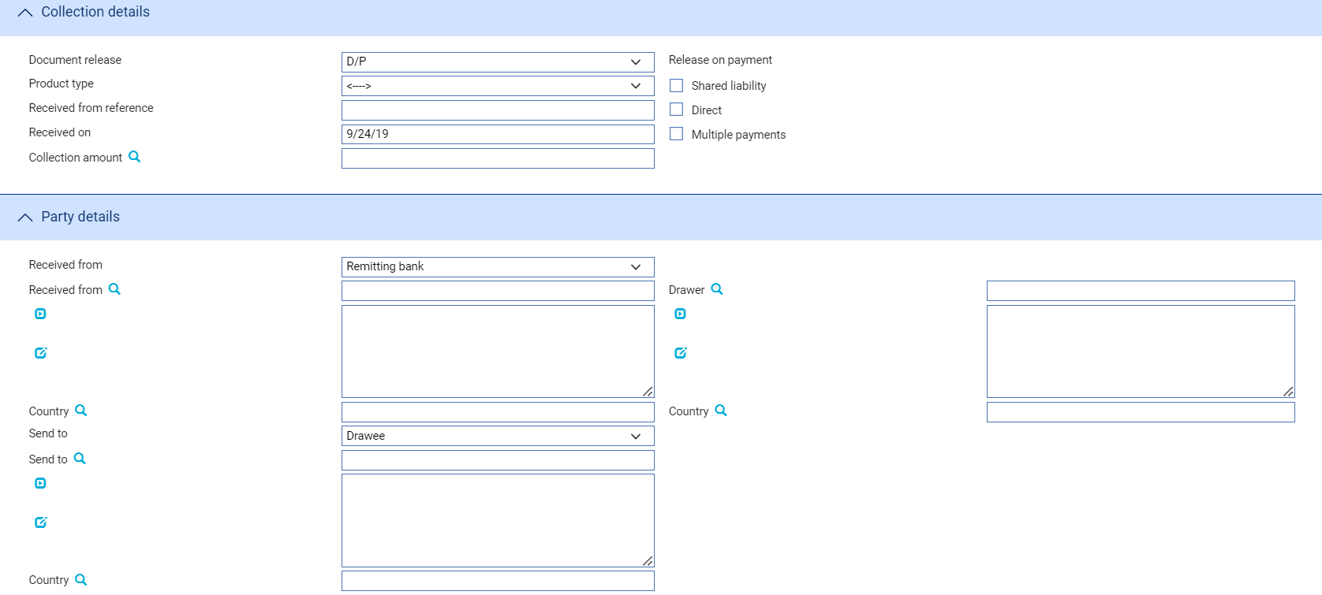

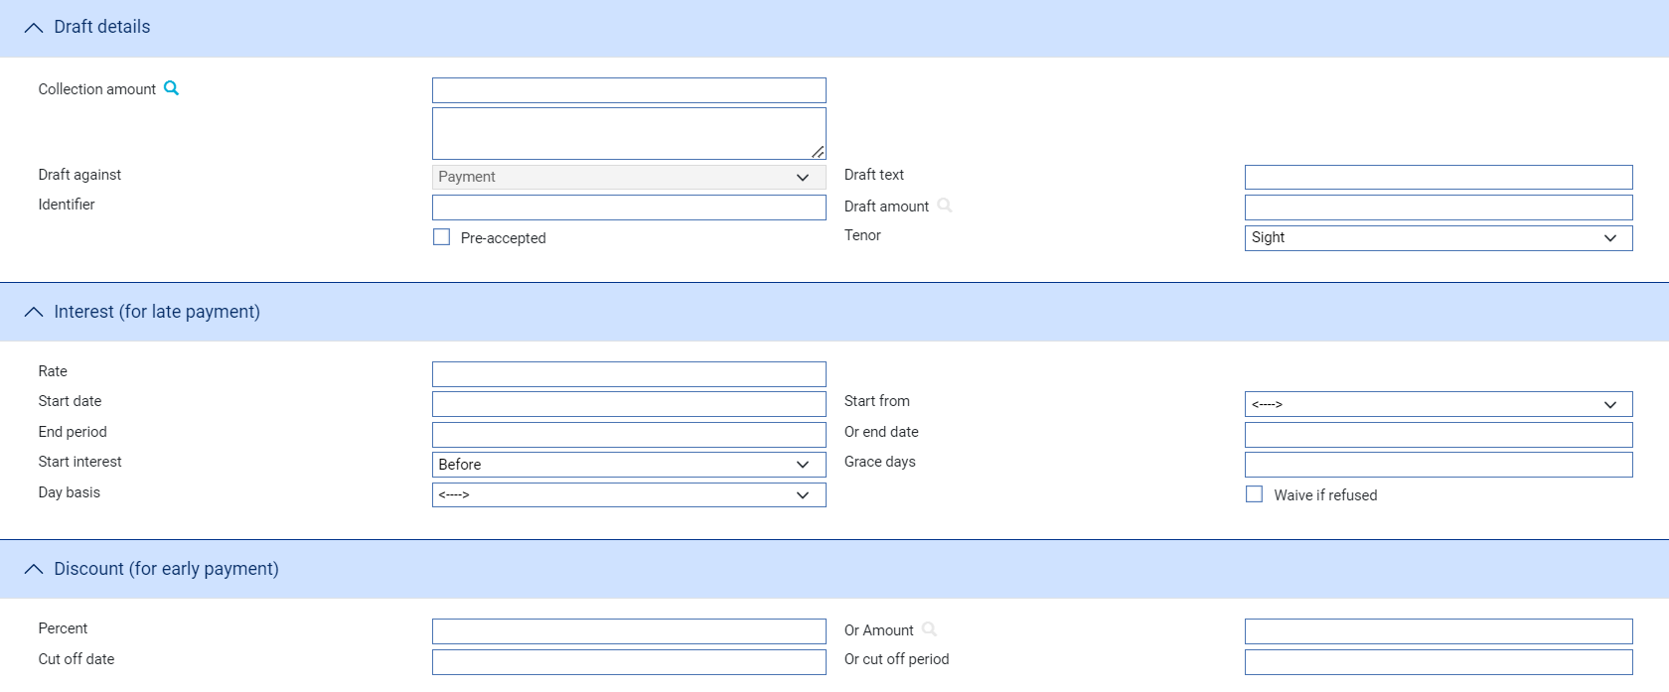

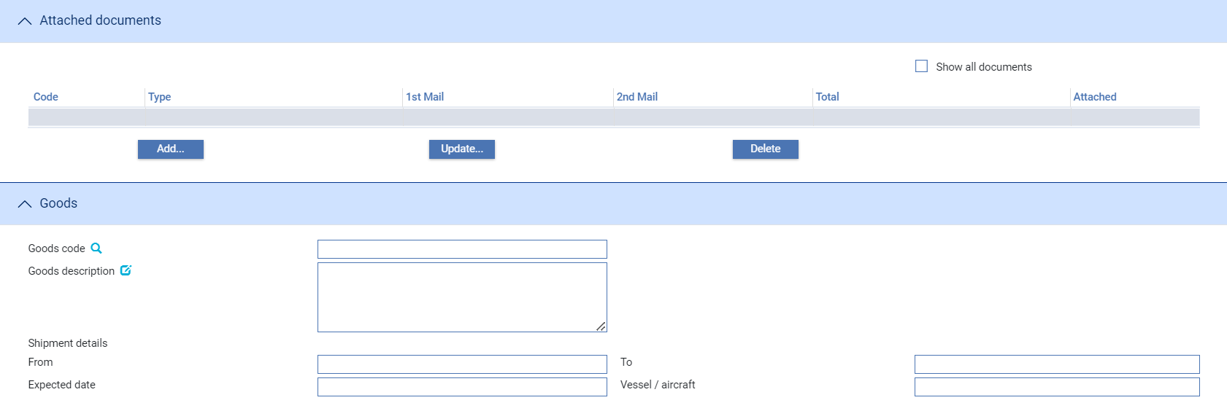

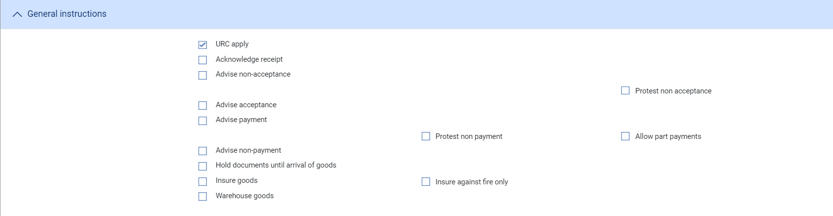

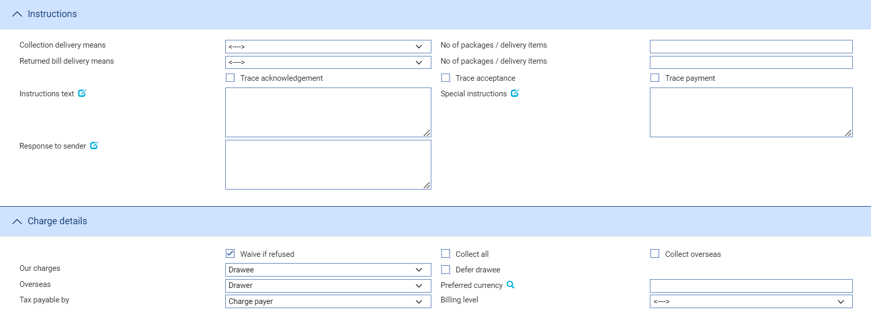

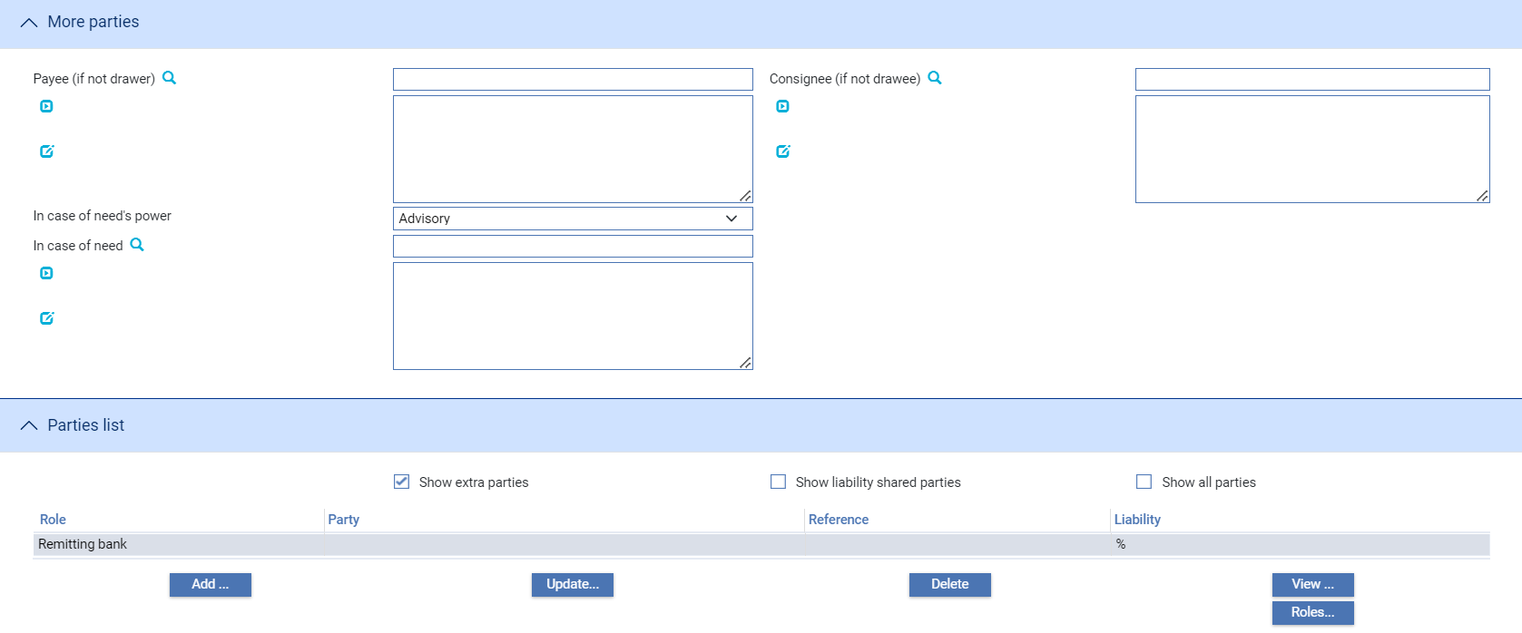

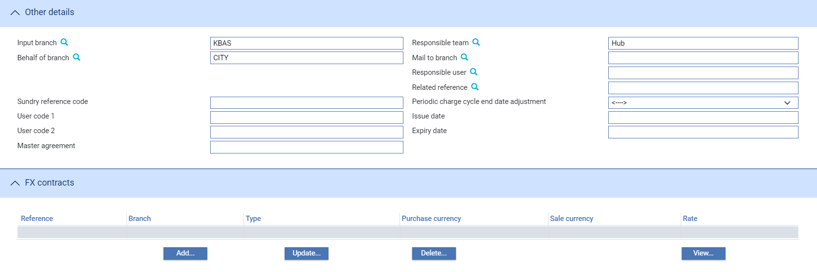

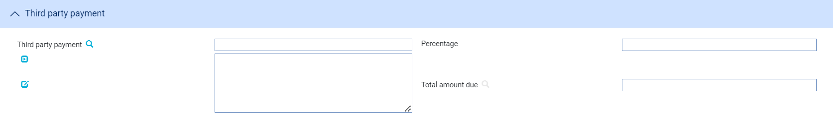

The system uses the following panes to enter details of a collection order:

* The Collection Details Pane (see page 15)
* The Party Details Pane (see page 17)
* The Draft Details Pane (see page 17) (including interest for late payment and discount for early payment)
* The Attached Documents Pane
* The Goods Pane (see page 19)
* The General Instructions Pane (see page 19)
* The Instructions Pane (see page 21)
* The Charge Details Pane (see page 21)
* The More Parties Pane (see page 22)
* The Party List Pane
* The Other Details Pane (see page 22)
* The FX Contracts Pane
* The Third Party Payment Pane (see page 23)
* The Deal Details Pane (see page 24)

Instructions on using the Attached Documents pane, the Party List pane and the FX Contracts pane are given in the Common Facilities User Guide – Trade Innovation.

### The Collection Details Pane

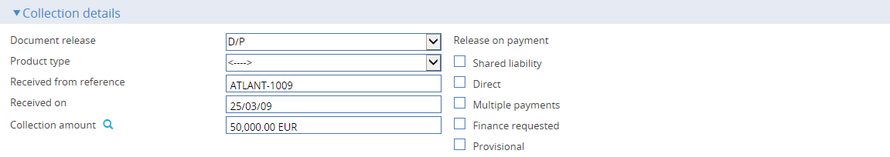

The following table explains what to enter into the fields in the Collection Details Pane:

|  |  |
| --- | --- |
| Field | What to Enter |
| Document Release | Specify the condition on which the financial or commercial documents accompanying the collection order are to be released. Select from one of the following:   * D/P (release documents against payment) * D/A (release documents against acceptance) * Pour Aval * Other   If you specify 'Other', the system creates an additional field in which you can specify some other condition. |
| Product Type | If your bank has set up product types for collection orders, select the appropriate one from the drop-down list in this field. |
| Received From Reference | The reference given to the collection order by the party from which you received it.  The value you enter here is compared to the Issuer's Reference for any collection order within the same product on your database. If the system finds a duplicate reference, it issues a warning message. |
| Received On | The date on which the collection order was received. This defaults to today's date. |
| Collection Amount | The total amount of the collection order. |
| Shared Liability | Check this box if any liability for the collection order is to be shared with a third party, such as an export credit guarantor. |
| Direct | Check this box if this is a direct collection order. |
| We Will Avalise | Displayed if you specify 'Pour Aval' or 'Other' in the Document Release field. Check this box if your bank intends to avalise drafts on the collection order, otherwise leave the check box blank. |
| Multiple Payments | Check this box if the collection order is to allow multiple payments. When you click **Refresh** an additional Pane - the Payment pane - is displayed which allows you to enter details of each draft in turn. |
| Finance Requested | For an outward collection order, check this box if the exporter has requested an advance or negotiation payment. A ‘Finance’ button is enabled. Pressing this button enables a subsidiary finance deal to be entered. |
| Provisional | Enables Provisional event’ functionality. Check this box if the event is to be treated as ‘Provisional’, in which case a subsequent version of the event is required before the event can be completed. Checking this box in conjunction with the ‘Finance requested’ box, enables a ‘Finance offer’ button, Pressing this button allows a subsidiary finance deal to be entered so that an offer of finance may be made to your bank’s customer. On completion of the Create event, both it and the subsidiary finance deal are held in a provisional state, pending receipt of your customer’s acceptance or rejection of the offer. See pages 42 – 44, |
| Automatically create follow-on event | Checking this box enables the system to automatically create a subsequent version of the event at an Input step; otherwise a new version of the event needs to be created manually. |
| Gateway transaction refused | Displayed if the collection instruction has been received via the gateway. Check this box if your bank wishes to reject the request to create and remit the collection. |

### The Party Details Pane

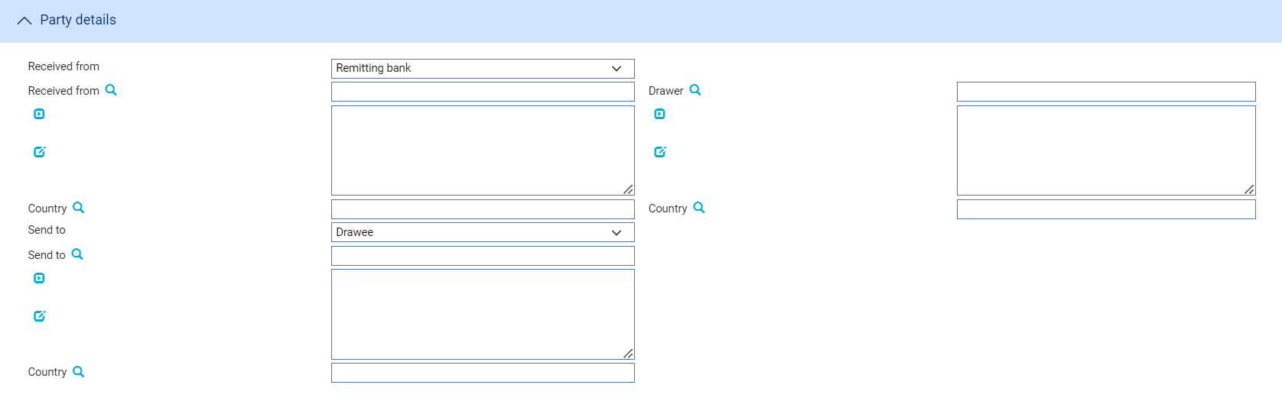

The following table explains what to enter into the fields in the Parties pane. During an Input step all four parties are mandatory:

|  |  |
| --- | --- |
| Field | What to Enter |
| Received From | The party from whom your bank received the collection order details. The drop-down list displays the standard list of parties for your system. |
| Country | The Received From party's country. |
| Drawer | The Drawer fields are displayed only if you do not specify the drawer in the Received From field.  During an Input step this field is mandatory if you have not specified the drawer in the Received From field. |
| Country | The drawer's country. |
| Send To | The party to whom the collection order is to be sent. The drop-down list displays the standard list of parties for your system. |
| Country | The Send To party's country. |
| Drawee/Country | These fields are displayed only if you do not specify the drawee in the Send To field. Use them to identify the drawee and their country.  During an Input step the Drawee field is mandatory if you have not specified the drawee in the Send To field. |

### The Draft Details Pane

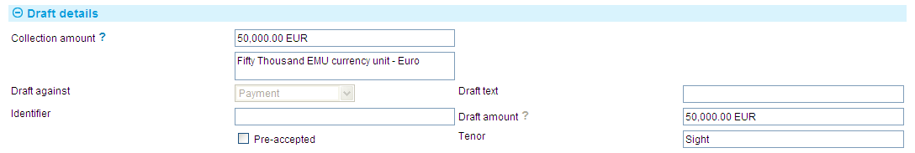

The Draft Details pane displays details of the draft or drafts associated with the collection order. By default, the system assumes a single draft and so displays the value of the full collection order in the Amount field, using 'Sight' as the tenor.

If you check the Multiple Payments field, the pane changes pane to allow you to define each draft in turn.



Click **Add**.



In the window that appears amend the amount and any other draft details - the following table explains what to enter into the fields in this window. Click **OK** to close the window when you have completed input.

|  | Field | What to Enter |
| --- | --- | --- |
|  | Draft Against | The value selected in this field can be changed only if you have specified 'Other' in the Document Release field.  Indicate whether documents relating to this draft are to be released against payment, acceptance or acceptance pour aval. By default, the system uses the value entered against the Document Release field. |
|  | Draft Text | Free format text identifying the document against which the payment is to be made. |
|  | Identifier | An identifier for the payment, such as a draft number, to differentiate it from other payments associated with the collection order. |
|  | Draft Amount | The amount of the payment in the collection order currency. |
|  | Pre-accepted | This box is only displayed if the Draft Against field is set to Payment. Use it to specify whether or not a draft against payment has been accepted before the bank receives it. By default the box is blank, indicating that the draft has not been pre-accepted. Check the box if the draft is pre-accepted.  If this field is checked, the Tenor field is replaced by a Maturity Date field in which you can enter a maturity date for the pre-accepted draft. |
|  | Tenor | Select the tenor of the draft. |
|  | Rate | The interest rate to use to calculate late payment interest. |
|  | Start Date/Start From | Either enter an actual date at which interest will begin to be charged into the Start Date field, or select a trigger date, such as' Arrival of Goods', using the Start From field.  By default, the system uses the maturity date of the payment, displayed in the Start Date field, as the date interest begins to be charged. |
|  | End Period/Or End Date | Specify the point at which the system should cease charging interest, either as a date, or as a text instruction (for example, 'until arrival of proceeds'). |
|  | Start Interest | Enter a number into the Grace Days field to specify a days grace period following the start date, before the system begins to charge interest. If you do, you can also specify whether interest is to be charged for the whole overdue period (Before), or just from the end of the days grace period (After). |
|  | Days Basis | The system will use as a default the interest days basis associated with the collection order currency. You can override this by selecting one of the values from the drop-down list. These values are listed in the Common Facilities User Guide – Trade Innovation. |
|  | Waive if Refused | Indicate whether interest is to be waived if refused or not. By default, the box is checked, indicating that interest is to be waived if refused. Click once on the box, so that it becomes blank, if interest is not to be waived if refused. |
|  | Percent/Or Amount | Define the discount either as a percentage or as an amount. |
|  | Cut Off Date/Or Cut Off Period | The date until which the discount will be given. You can specify an actual date, or enter text, for example 'Maturity date'. |

### The Goods Pane

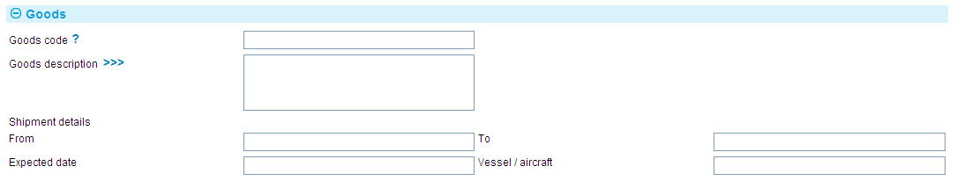

The fields in the Goods pane permit you to define the goods relating to the collection order. For documentary collection orders, you must select a value in the Goods Code field from a standard list of goods set up for your system. Use the Goods Description field to enter any additional information that may be necessary about the goods.

The Shipment Details fields permit you to enter details of the arrangement for shipping the goods. Use the From and To fields to identify the ports from which and to which the goods are to be transported, and enter the expected date of arrival of the goods into the Expected Date field. The Vessel/Aircraft field allows you to enter a description of the carrier being used to transport the goods.

### The General Instructions Pane

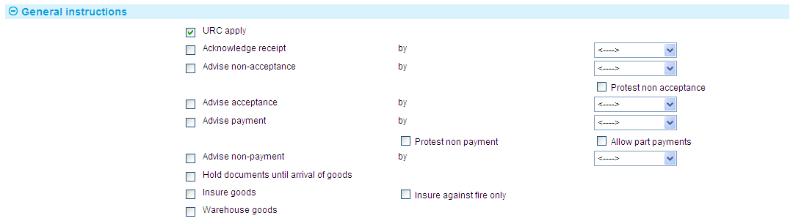

The following table explains what to enter into the fields in the Instructions pane:

| Field | What to Enter |
| --- | --- |
| URC Apply | Indicates that the collection order will be processed according to the Uniform Rules for Collections. By default, this is set to indicate compliance, but you can click once on this box so that it becomes blank to indicate non-compliance for this collection order. |
| Acknowledge Receipt | Check this box if an acknowledgement of receipt of the collection order is required. In the second field select the method by which the advice is to be sent. |
| Advise Non-Acceptance | Check this box if notification is required, should the collection order drafts not be accepted. In the second field select the method by which the advice is to be sent. |
| Advise Acceptance | Check this box if notification of acceptance is required for the collection order drafts. In the second field select the method by which the advice is to be sent. |
| Protest Non-Acceptance | Check this box if the bank is to protest non-acceptance by the drawee. |
| Advise Payment | Check this box if notification of payment is required. In the second field select the method by which the advice is to be sent. |
| Protest Non-Payment | Check this box if the bank is to protest non-payment by the drawee. |
| Allow Part Payment | Indicates whether the principal party can accept offers of partial payment via the collecting bank or presenting bank. |
| Advise Non-Payment | Check this box if notification of non-payment is required. In the second field select the method by which the advice is to be sent. |
| Hold Documents Until Arrival of Goods | Check this box if the bank is to retain the documents until the arrival of the goods. |
| Insure Goods | Check this box if the bank is to insure the goods. |
| Insure Against Fire Only | Check this box if the bank is to insure the goods, but only against fire. |
| Warehouse Goods | Check this box if the bank is to warehouse the goods until they are released to the drawee. |

### The Instructions Pane

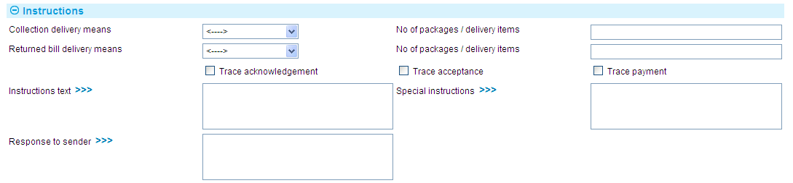

The following table explains what to enter into the fields in the Instructions pane:

|  |  |
| --- | --- |
| Field | What to Enter |
| Collection Delivery Means | Use the drop-down list to specify how the collection order is to be delivered. Select from the following:   * First Class Mail * Recorded Delivery * Registered Mail * Air Mail * Registered Air Mail * Hand Delivery * Collect * Courier |
| Returned Bill Delivery Means | Specify how returned bills are to be delivered. The permitted value is the same as for Collection Delivery Means and Delivery Number, above. You only need to specify anything here if the values are different. |
| No of packages/Delivery Items | Use the first of the two fields to specify how many mailings there will be.  Use the second to specify how many drafts are to be returned once accepted. |
| Trace Acknowledgement | Check this box if the drawer has requested a tracer for acknowledgement of the collection order. |
| Trace Acceptance | Check this box if the drawer has requested a tracer for acceptance of drafts. |
| Trace Payment | Check this box if the drawer has requested a tracer for payment of drafts. |
| Instructions Text | Any additional standard instructions regarding the collection order relating to the values entered into the previous fields. |
| Special instructions | Any special instructions regarding the collection order in addition to those relating to the information already given in the fields in this window. |
| Response to Sender | You may use this field to enter the text of the required response used when an acknowledgement of the receipt of the collection order is generated. |

### The Charge Details Pane

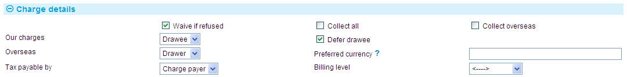

The following table explains what to enter into the fields in the Charges Details pane:

|  |  |
| --- | --- |
| Field | What to Enter |
| Waive if Refused | Check this box if charges are to be waived for the collection order if the drawee refuses to pay charges. |
| Collect All/Collect Overseas Only | Check one of these boxes to indicate whether the overseas bank is to collect all charges relating to the collection order, or just their own charges. |
| Our Charges | Select the party - drawer or drawee - who will pay your bank's charges. |
| Defer | Check this box if the charges for your own bank are to be collected now or deferred until payment. If you leave it blank they are collected as the event is released. |
| Overseas | Select whether the overseas charges resulting from the collection order are to be paid by the drawer or the drawee. |
| Preferred Currency | Select the currency in which charges are to be paid. The system uses as default the currency specified on the product for collection of charges or, if this is blank, the currency of the collection order. |
| Tax Payable By | Use the boxes in this pane to indicate whether any tax due on the collection order is to be paid by the party who is your bank's customer (for inward collection orders, this will be the drawee, and for outward collections the drawer), or by the party due to pay your bank's charges. |
| Billing Level | Select whether charges for this license should be billed at customer level, transaction level or product level. |

### The More Parties Pane

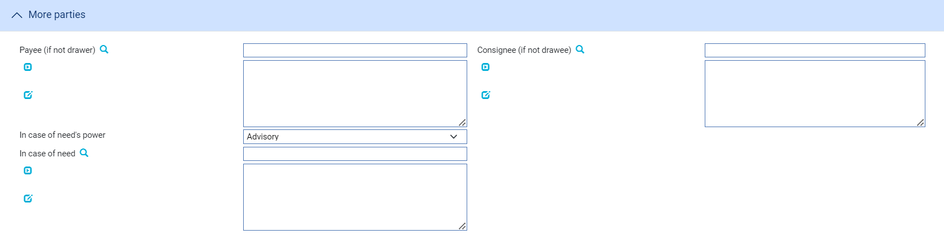

Use the Payee fields to identify a payee, if the payee is not the drawer.

Use the Consignee fields to identify a consignee, if the consignee is not the drawee.

Use the In Case Of need fields to identify a representative for the exporter in case of need, then select one of the two values in the In Case Of Need's power field to indicate the level of authority the party will have.

### The Other Details Pane

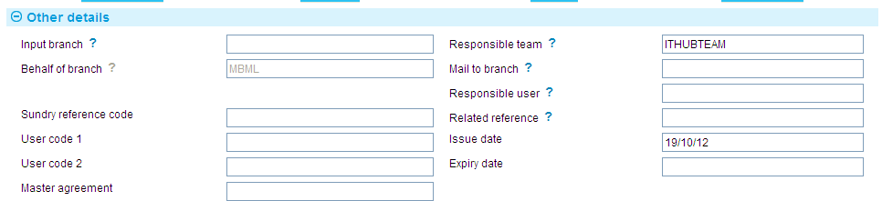

The following table explains what to enter into the fields in the Other Details pane. This pane may also contain fields defined by your bank:

|  |  |  |
| --- | --- | --- |
|  | Field | What to Enter |
|  | Input Branch | The input branch for the transaction. The input branch is set from either :  the accounting branch from the user’s team, or  the transaction branch for user if the user has a default transaction branch or is locked to a specific branch, or  a branch associated with the user where the user can enter transactions for several branches for a team |
|  | Behalf Of Branch | The behalf of branch for the transaction as entered by the user or set from the incoming SWIFT or gateway message. The behalf of branch determines the parameter sets that are to be used to generate charges, documents, postings, etc. during transaction processing. The branch can be changed to any other branch within the same main banking entity that shares the same parameter sets. |
|  | Sundry Ref Code /User Code 1/ User Code 2 | You may use these fields to enter values for analysis purposes. Your bank will have devised its own system for using these fields. |
|  | Master Agreement | A reference for a master agreement collection order for a party who is your customer. |
|  | Responsible Team | The team that has overall responsibility for the master e.g. as the contact to resolve any queries or issues regarding the master and associated events. The system defaults the responsible team when creating the transaction as follows:  Manual – set from team creating the transaction  Gateway – set from the team specified on the incoming message (if present and valid) otherwise to the team to which the transaction is assigned through workflow allocation based on the behalf of branch  SWIFT – set to the team to which the transaction is assigned through workflow allocation based on the behalf of branch  It can be changed, if required, to either the team associated with the primary customer, default team for the product or the user’s current team. |
|  | Mail To Branch | The mail to branch can be set to any branch within the main banking entity of the behalf of branch. |
|  | Responsible User | A user that has responsibility for the master e.g. as the contact to resolve any queries or issues regarding the master and associated events. This can be any user assigned to the responsible team. |
|  | Related Reference | If the collection order is related to another trade finance transaction, use the browser to select the master record for the transaction. The system displays the Open Master window, in which you can identify the required master record. |
|  | Issue Date | The date on which the collection order was created by the principal party. |
|  | Expiry Date | An expiry date for the collection order. You may use today's date, if you foresee no further involvement in the collection order on the part of your bank, in which case the system will identify the collection order master record as due for expiry during the next end-of-business-hours batch processing phase and subsequently expire it, following the appropriate days grace period. |

### The Third Party Payment Pane



The following table explains what to enter into the fields in the Third Party Payment pane:

|  |  |
| --- | --- |
| Field | What to Enter |
| Third Party Payment | If a payment is being made to a third party, identify the party to whom the payment is being made. |
| Percentage/ Total Amount Due | Define how much is to be paid to the third party, either as a percentage or as an actual amount, in the currency of the collection order. |

### The Deal Details Pane

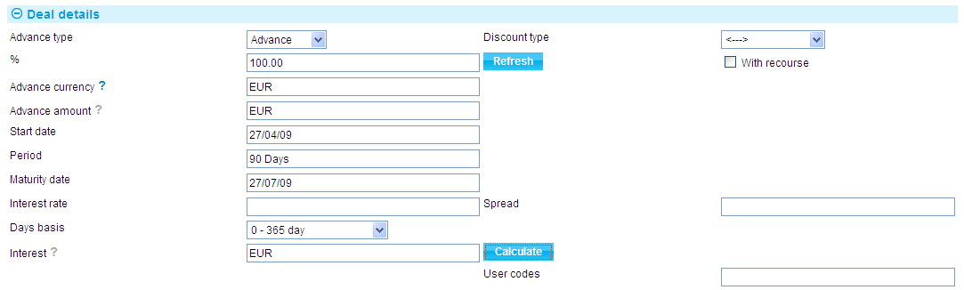

The Deal Details pane is displayed if you check the **Finance Requested** box and click **Refresh**, and if your bank has not implemented the financing module. It allows you to enter details of a loan. When you enter details of a loan as part of the Create event, the system treats the details as part of the Create event and validates them and, if required, performs any review step on them together with the Create event data.

The following table explains what to enter into the fields in this pane:

|  |  |  |
| --- | --- | --- |
|  | Field | What to Enter |
|  | Advance Type | Select the type of deal. If you select 'Advance', enter the percentage of the collection order to be advanced into the second field.  If you select 'Negotiation', then the advance will be for 100% of the collection order value. |
|  | Discount Type | Indicate when interest is to be paid. Select 'Discount' if interest is to be paid at inception; or 'Discount to Yield' if the discount to yield formula is to be used to calculate the discount instead of the standard discount formula.  Click Refresh. The system displays additional fields. Use the Discount Paid By field to select who will pay the discount interest on the loan - the credit party or the debit party. The Discount Interest field and the Net Amount field display the discount amount and net amount. |
|  | With Recourse | Check this field if the loan is with recourse. |
|  | Advance Currency | The currency of the loan, if different from the currency of the collection order.  If you enter a currency here that is different from the collection order currency, click Refresh to display additional fields used to identify either the code of the exchange rate to be used to derive the exchange rate to be used to convert the loan amount from the collection order currency or an actual exchange rate.  When you have selected an exchange rate, the system calculates and displays the converted amount in the Advance Amount field. |
|  | Advance Amount | If you have selected 'Advance' in the Advance Type field, enter here the amount that is to be advanced. The percentage field will be automatically recalculated. If you have selected 'Negotiation', this will be the entire amount of the collection order. |
|  | Start Date | The start date of the loan. |
|  | Period | The deal period for the loan. When you click Refresh the system calculates and displays the maturity date. |
|  | Maturity | The maturity date, if known. Typically, this will be left blank to allow the deal to proceed as an open date deal. If you have selected 'Discount', then you must specify a maturity date either directly or by using the Period field. |
|  | Rate | The overall rate at which interest or discount is to be calculated (including the spread). |
|  | Spread | The spread rate that has been added to the interest rate. This is used for reporting purposes only. |
|  | Days Basis | The days basis to be used to calculate the interest. A list of values is given in the Common Facilities User Guide – Trade Innovation. |
|  | User Codes | You may use this field to enter a value for analysis purposes. Your bank will have devised its own system for using this field. |

## The Collection Order Master Summary Window

Once you have created a collection order, the system will display the basic details of that collection order using the Master Summary window.

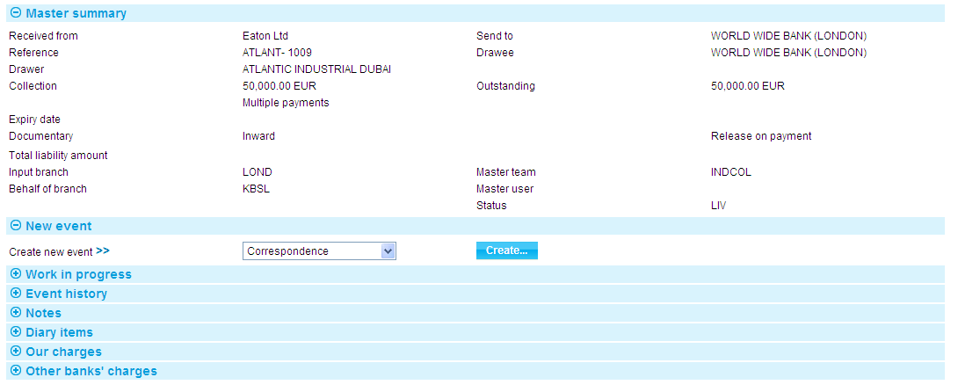

For more information on how the various panes and buttons in this window work see the Common Facilities User Guide – Trade Innovation.

# Receiving Acknowledgements

The system allows you to record details of an acknowledgement for one or more payments received from the collecting bank (if you are the remitting bank) or from the presenting bank (if you are the collecting bank).

The remitting bank or presenting bank creates and sends acknowledgements after entering details of the collection order, if acknowledgement is required, either for the whole collection order or for individual payments on it. Since payments may be acknowledged separately, you may receive several acknowledgement advices for the same collection order.

Once a payment has been acknowledged, any acknowledgement tracers set up for it are automatically stopped.

## Acknowledging Payments via Swift

For acknowledgements received via SWIFT, the system uses the SWIFT MT410 message to create an acknowledgement event at an Input step with a status of Awaiting for the correct collection order master record.

Where an MT410 message is used to acknowledge more than one payment (the SWIFT message can support up to ten), the system automatically splits the message into separate acknowledgement messages and uses them to create a separate acknowledgement event for each payment.

For acknowledgements received via SWIFT, your bank can record all acknowledged payments using a single Receive Acknowledgement in the following way:

1. View each of the acknowledgement events created by the system to establish which payments are being acknowledged.
2. Open a single acknowledgement event and use it to record all of those payments as acknowledged.
3. Select each of the other acknowledgement events in turn in the Work in Progress pane in the Master Summary window. Select and abort each one in turn.

## Entering Details of an Acknowledgement

To enter details of an acknowledgement you have received, in the Master Summary window select 'Receive Acknowledgement' from the Create New Event drop-down list. The system opens the event at either at a Log step or Input step. Depending on how your system is configured, panes and fields available in log steps can be tailored for each data capture step. See the *SDK - Screen Tailoring Guide* – Trade Innovation for details.

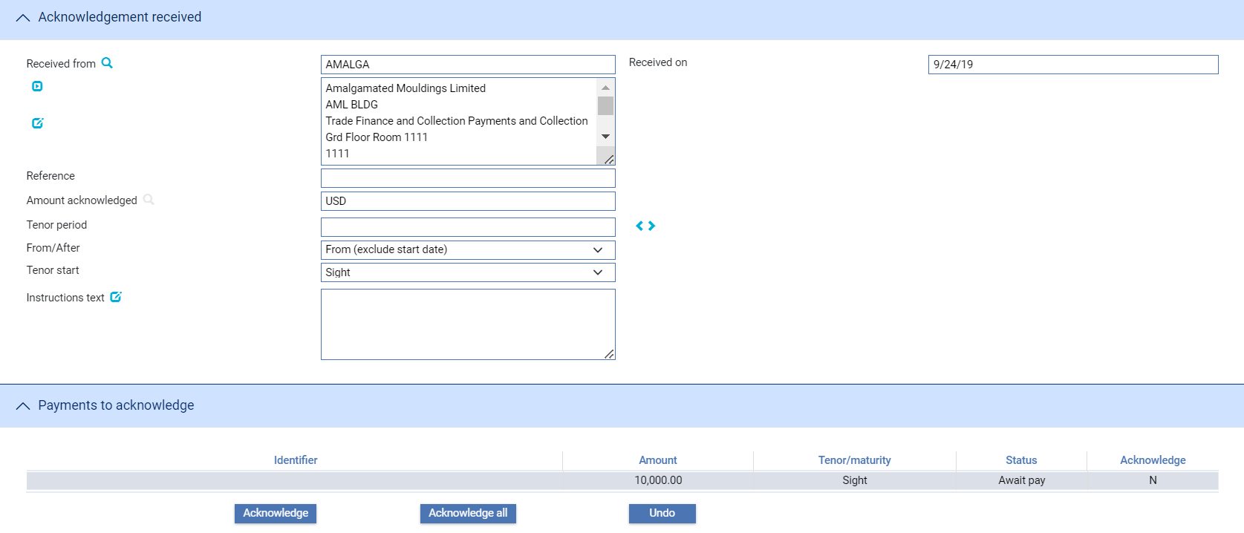

If the acknowledgement has been received via SWIFT, then the system will display the information from the SWIFT message in the appropriate fields, and you will only need to identify which payments are being acknowledged.

The following table explains what to enter into the fields in the Acknowledgement Received pane:

|  |  |
| --- | --- |
| Field | What to Enter |
| Received From | The reference of the bank from which you received the acknowledgement advice. |
| Received On | The date the acknowledgement was received. The system uses today's date as the default. |
| Reference | The sender's reference for the collection order. |
| Amount Acknowledged | The amount being acknowledged. This is not necessarily the amount of the collection order - it may be the amount for a single payment under the collection order. The amount is followed by the code of the currency in which it being shown - this will be the currency specified when the collection order was created. |
| Tenor Period/From/After/ Tenor Start | Use the Tenor Period fields to define the period, then use the From/After and Tenor Start fields to define the date and how the period defined is to be applied to it to arrive at the payment due date. If the tenor is 'from', then the system calculates the tenor as starting on the day of the event; if it is 'after', the system calculates the tenor as starting on the day after the event.  In the Tenor Start field you can select:   * Sight * Bill of Exchange * Bill of Lading * Air Waybill * Invoice * Shipment Date * Arrival of Goods   To define the payment due date as an actual date click , then enter the date in the field that appears. |
| Instructions | Any instructions received with the acknowledgement. |
| Payments To Acknowledge | The fields and buttons in this pane allow you to identify which payments have been acknowledged. |

The Payments to Acknowledge pane lists all payments associated with the collection order.

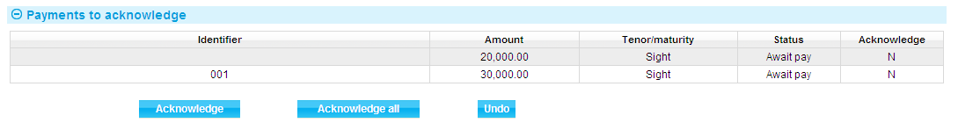

The pane lists information about each payment under the following headings:

|  |  |
| --- | --- |
| Heading | What it Shows |
| Identifier | The payment identifier. |
| Amount | The amount of the payment, followed by a code indicating the currency of the collection order. |
| Tenor/Maturity | The term of the payment. |
| Status | The status of the payment. A list of values is given in the Common Facilities User Guide – Trade Innovation. |
| Acknowledge | Indicates whether the payment has been acknowledged in this event (Y) or not (N). |

The information in the Amount Acknowledged pane should enable you to identify which payments are being acknowledged.

To select an individual payment as acknowledged, select the payment by clicking on it once so that it is highlighted, then click **Acknowledge**. The system flags the payments as acknowledged and changes the value in the Acknowledge column for that payment to Y. (If the payment selected has already been acknowledged in a previous event the Acknowledge button is disabled.)

To select and flag as acknowledged all the payments in this pane, click **Acknowledge All**. The value shown in the Acknowledge column for each payment changes to Y to indicate that it has been acknowledged.

1. By default, this button is only available if the Acknowledge Receipt field was checked in the create event. It allows you to acknowledge all the payments yet to be acknowledged at once, rather than using the Acknowledge button separately on individual payments. However, if your bank has set the AlwaysAllowCollnDraftToBeAck system option, then collection order drafts can be acknowledged irrespective of whether the Acknowledge Receipt field was checked on the master.

The Undo button allows you change the status of payments acknowledged in this event back to unacknowledged. Select the payment whose status you want to revert, then click **Undo**. The value in the Acknowledge column for the selected payment is changed back to N.

# Acceptance

The Acceptance function allows the following:

* Accept one or more draft associated with a collection order
* Record acceptances received
* Advise non-acceptance or non-payment of one or more draft
* Record advices of non-acceptance or non-payment received

The collection order details specify whether an advice of acceptance is required for the collection order or not.

Acceptance advices are entered using the Accept event. Accept events can only be entered against collection orders whose document release conditions were set as one of the following:

* D/A (release documents against acceptance)
* Pour Aval

As each payment is accepted, you use the Accept event to flag that payment as accepted and record a maturity date against it, as follows:

* If you are the presenting bank, you use the Accept event to record the maturity date and create an acceptance advice for one or more payments and send it to the collecting bank
* If you are the collecting bank, you use the Accept event to record the maturity date and create an acceptance advice for one or more payments and send it to the remitting bank. You may also use an Accept event to record details of an acceptance advice for one or more payments received from the presenting bank
* If you are the remitting bank, you use the Accept event to record the maturity date for one or more payments received from the collecting bank

Since payments may be accepted separately, you may create or receive several acceptance advices for the same collection order.

If you accept more than one payment within the same acceptance event, the system will create a single MT412 message containing all acceptances.

## Acceptance via Swift

If acceptance is received via SWIFT, then the system will automatically use the SWIFT MT412 message to create an acceptance event at an Input step with a status of 'Awaiting' for the correct collection order master record.

Where an MT412 message is used to accept more than one payment, the system automatically splits the message into separate acceptance messages and uses them to create a separate Accept event for each payment. Your bank can record all such payments using a single Accept event in the following way:

1. View each of the Accept events created by the system to establish which payments are being accepted.
2. Open a single Accept event and use it to record all of those payments as accepted.
3. Select each of the other Accept events in turn in the Work in Progress pane in the Master Summary window. Select each one and then abort it.

## Acceptance and Payment Events

For inward collection orders, your bank can configure the system so that a payment action is generated automatically in the diary for acceptances pour aval and acceptances where your bank holds the draft. This is controlled by the system option AutoCreateCollectionPayEvents - see the System Tailoring User Guide – Trade Innovation.

A separate diary action is generated for each draft.

Depending on how your bank has configured Payment events, these diarised payment actions may be used to create a Payment event automatically during overnight processing when settlement falls due; or they may need to be actioned manually before a Payment event is created from them - see the Common Facilities User Guide – Trade Innovation for instructions.

In the diary, the Description column shows the draft identifier, the amount (with currency) of the draft, and its value date.

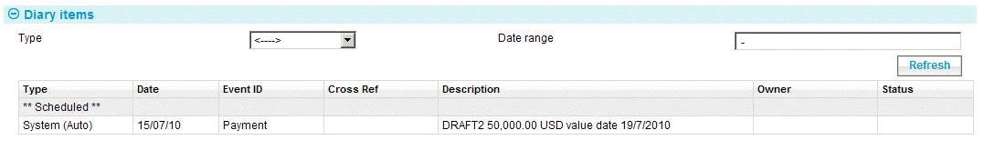

The diary action date is calculated using the value set up for the currency's Advice - SWIFT Days Advance field, see the Static Data Maintenance User Guide – Trade Innovation in order to allow the Payment event to be completed and funds settled by the value date. You can amend this date.

If the status of a draft that has been used in this way to create a diarised payment action subsequently changes (as a result of an Amend event, an Adjust event or a Non-acceptance event) so that it is not accepted or accepted only against payment, then the related action is removed from the diary. If the details of the draft are changed, then the information held against the diarised payment action is amended accordingly.

## Entering Details of an Acceptance

To create an acceptance advice, or to enter details of an acceptance advice you have received, in the Master Summary window select 'Accept' from the Create New Event drop-down list and click **Create**. The system opens the event at either a Log step or Input step, depending on how the Workflow orchestration controlling the event is configured. See the *Workflow Tailoring User Guide* – Trade Innovation for details.

A Log window and an Input window both have the same input fields, and the same window is used to both create and send an acceptance advice and to record details of an acceptance advice. The same window is used for all four types of collection order processed by the system.

The window used during an Input step allows you to enter full details of an acceptance of one or more collection order payments.

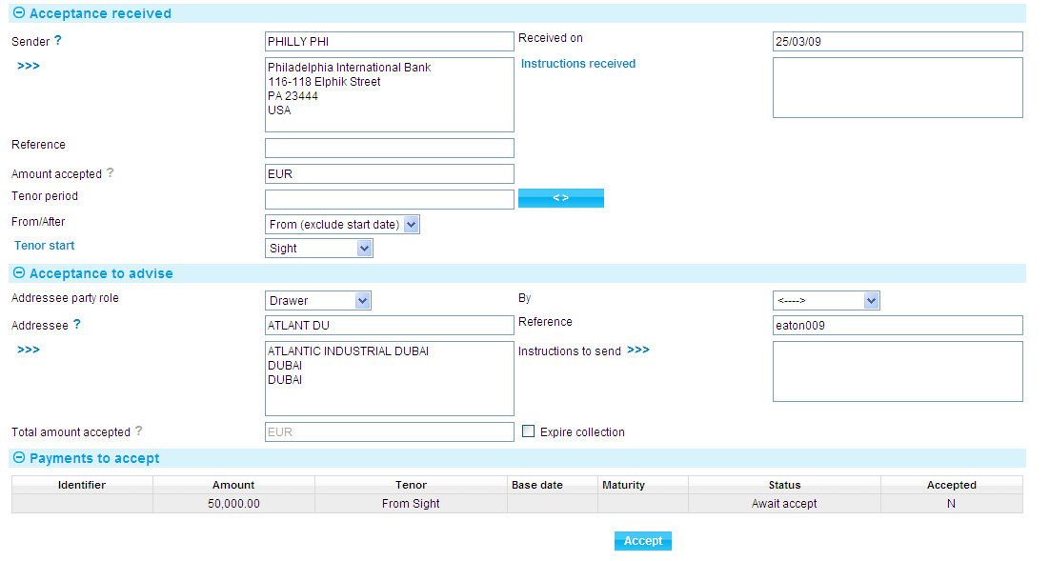

If you are entering details of an acceptance advice you have received, use the fields in the Acceptance Received pane to record its details.

You can also use this window to enter details of an acceptance advice you have received into the Acceptance Received pane, and then use those details to create an acceptance advice for another party by filling in the fields in the Acceptance to Advise pane.

The fields in the Payments to Accept pane allow you to flag payments as accepted. They are used in the same way, whether you are entering details of an acceptance advice you have received, or one you intend to send.

The following table lists the fields in the Acceptance Received and Acceptance to Advise panes and explains what to enter into them:

| Field | What to Enter |
| --- | --- |
| Sender | The sender of the acceptance advice. |
| Received On | The date you received the acceptance advice. The system uses today's date as a default. |
| Reference | The sender's reference for the collection order. |
| Instructions Received | Any instructions received with the acceptance. |
| Amount Accepted | The amount being accepted. This is the total of all payments being accepted on this advice. The amount is followed by the code of the currency in which it being shown - this will be the currency specified when the collection order was created. |
| Tenor Period/From/After/ Tenor Start | Use the Tenor Period fields to define the period, then use the From/After and Tenor Start fields to define the date and how the period defined is to be applied to it to arrive at the payment due date. If the tenor is 'from', then the system calculates the tenor as starting on the day of the event; if it is 'after', the system calculates the tenor as starting on the day after the event.  In the Tenor Start field you can select:   * Sight * Bill of Exchange * Bill of Lading * Air Waybill * Invoice * Shipment Date * Arrival of Goods   To define the payment due date as an actual date click , then enter the date in the field that appears. |
| Addressee Party Role/Addressee | The party to receive the acceptance advice. The system uses as a default the party defined when creating the collection order using the Received From fields.  The drop-down list allows you to select one of the parties for the collection order. Once you select a party, the system automatically finds and displays their details in the fields below the Addressee field. |
| By | If you are creating an acceptance advice to be sent, use this field to specify the method of transmission. The system will use the transfer method specified on the collection order details as a default, if these exist; or else use the default transfer method, mail. |
| Reference | The addressee's reference for the collection order. |
| Instructions to Send | If you are entering details of an acceptance advice you intend to send, use this field to record any instructions. |
| Amount Accepted | The total amount being accepted. This is the total of all payments being accepted on this advice. Details of all payments being accepted are mapped to the SWIFT message, where applicable. |
| Expire Collection | Check this box if the collection order is to be expired. If you do this, the system will diarise expiry of the collection order, and subsequently book it off and delete it from the system in the usual way as part of daily batch processing once this Amend event has been released. |
| Margin Deposit | For an inward collection order the margin deposit fields may be present (this is controlled by the MarginDepositInInwardCollection system option, as described in the System Tailoring User Guide – Trade Innovation.)  See the Common Facilities User Guide – *Trade Innovation* for instructions on defining a margin deposit. |

The Payments to Accept pane lists all payments associated with the collection order, together with their status.

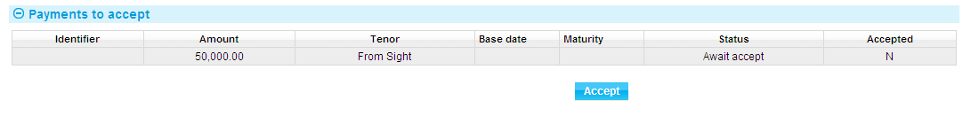

The pane lists information about each unaccepted payment under the following headings:

|  |  |
| --- | --- |
| Heading | What it Shows |
| Identifier | The payment identifier. |
| Amount | The amount of the payment, followed by the code of the currency of the collection order. |
| Tenor | The term of the payment. |
| Base Date | The date from which the payment period is calculated. |
| Maturity | The maturity date of the payment. |
| Status | The status of the payment. A list of values is given in the Common Facilities User Guide – Trade Innovation.  The system will not let you accept a payment if its status is Awaiting payment, Paid, Returned or Accepted and returned. |
| Accepted | Indicates whether the payment has been accepted in this event (Y) or not (N). |

To accept a draft, highlight it, and then click **Accept**. If document release is 'Pour Aval' or 'D/A' additional fields are displayed.

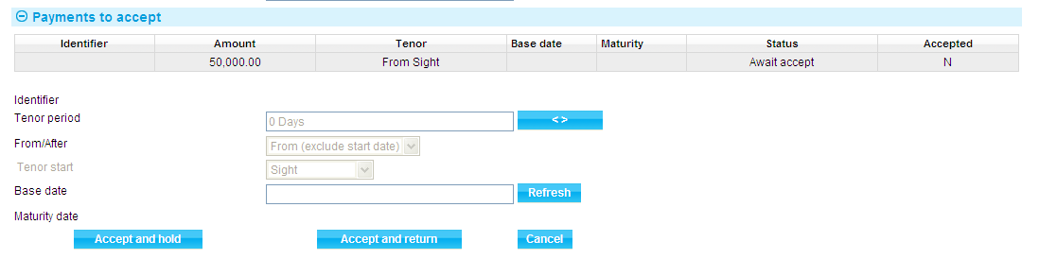

Use them to enter the tenor of the draft to be accepted (see the Common Facilities User Guide – Trade Innovation for instructions on entering tenor details). Then click **Refresh**. The system calculates and displays the maturity date. Alternatively, click  and use the fields that appear to enter a maturity date directly.

Click:

* The **Accept** and **Hold** to accept the payment, if the draft is to be held by one of the banks involved in the collection order until the drawee is ready to make the payment
* The **Accept** and **Return** to accept the payment, if you intend to return the draft to the drawer
* The **Accept** and **Aval**, which is displayed if the payment has a status of Awaiting Acceptance and Avalisation, to accept the payment. In this case the draft is held by one of the banks, normally the bank which avalised that draft

# Making Changes to a Collection Order

The system allows you to expire (discharge) or make amendments to certain details of a collection order at any point before it expires. You can amend instructions, payment details and the identity of the drawee and consignee. This is done using an Amend Collection event (see page 35).

Amendments are instituted by the remitting bank, on the instructions of the drawer.

* If you are the remitting bank, you will use the functionality described in this chapter to enter details of the amendment and then transmit them to the collecting bank
* If you are the collecting bank, you will use the functionality described in this chapter to enter details of the amendment and then, if you are using a presenting bank, to transmit them to the presenting bank
* If you are the presenting bank, you will use the functionality described in this chapter to enter details of the amendment

When you amend a collection order, the system retains the original details, thus preserving a complete history of all amendments. The original details can then be used in outward messages, if necessary.

The Amend Collection event can be used to expire or discharge a collection order - the Expire flag allows you to do this.

Amendments may also be sent via SWIFT using an MT430 message. When the system receives an MT430 message relating to a collection order, it uses it to create an amendment event for the appropriate master record at an Input step and with its status set to 'Awaiting'. You can then open the event and complete input.

If you make changes to a collection order draft that has been used to create a diary payment action (see page 30), those changes are reflected in the diary action. If the status of the draft changes so that it is not accepted or accepted only against payment, then the related action is removed from the diary. If the details of the draft are changed, then the information held against the diarised payment action is amended accordingly.

## Licenses

If a license is required for the collection order, there will be some additional processing when you make an amendment to the collection order. For example:

* If you make an amendment to the collection order after the Valid To date on the license has passed, the system will either reject the amendment or allow a new license to be added, depending on how your system has been set up
* If the amount and currency are changed, a reinstatement of any outstanding reserved value is made and then re-reserved for the new currency
* If the amount of the collection order is increased a reservation is automatically provided against the license. Likewise, if the amount of the collection order is decreased a reinstatement is automatically provided against the license. However, where there is more than one license linked you must manually reserve or reinstate against each license. You may also delete links or add in new license links
* If the type of collection order is changed, the new type must be one that is allowed by the license. Also, if you change the name of the drawee, the new name must be the same as the name on the license

See the Licenses User Guide – Trade Innovation for more details.

## Handling More than One Amendment at a Time

The system permits you to have more than one Amend Collection event in progress at the same time. Should a situation arise where a change is made to the master record date after an Amend Collection event has been initiated but before it has completed, a warning message is displayed when the Amend Collection event is next opened, identifying the event(s) responsible for the intervening changes. You can then decide how to ensure that the required changes are implemented.

## Amending a Collection Order

To amend a collection order, in the Master Summary window select 'Amend Collection' from the Create New Event drop-down list and click **Create**. The system opens the event at either a Log step or Input step, depending on how the Workflow orchestration controlling the event is configured. See the *Workflow Tailoring User Guide* – Trade Innovation for details.

A Log window and the Input window both have the same input fields, and the same windows are used to both create and record details of an amendment for all four types of collection order processed by the system.

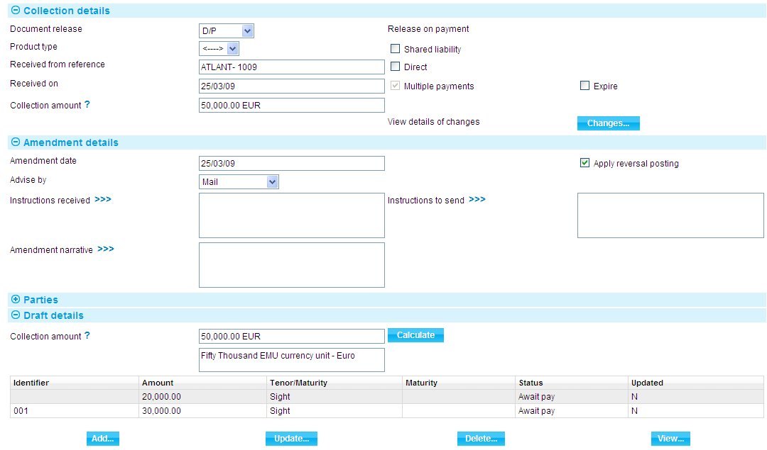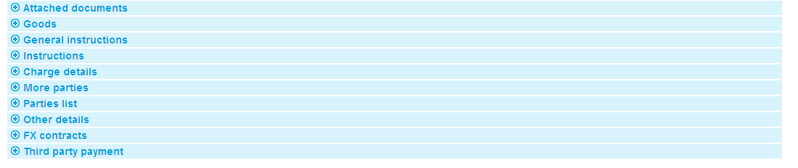

The fields displayed for input are a sub-set of those used when creating a collection order. The Changes button allows you to display any change made during the event (see page 40).

You will be required to amend payment details (see page 36) before you can save the Amend event if you wish to make any of the following changes:

* If you change the value in the Document Release field from D/P or Other to D/A or Pour Aval or vice versa
* If you change the amount of the collection order
* If you change a multiple-payment collection order to a single payment one

The following additional fields are present:

|  |  |
| --- | --- |
| Field | What to Enter |
| Expire | Check this box if the collection order is to be expired. If you do this, the system will diarise expiry of the collection order, and subsequently book it off and delete it from the system in the usual way as part of daily batch processing once this Amend Collection event has been released.  This facility enables you to cancel a collection order before it would normally expire. |
| Amendment Date | The date of the amendment. |
| Apply Reversal Postings | Leave this checked if your bank has set up reversal postings for the Amend Collection event and wishes to apply them when the event is released. |
| Advise By | The transmission method to be used to advise the amendment. |
| Instructions Received | Details of the instructions received by the remitting bank from the drawer. |
| Amendment Narrative | A summary of the changes to any instructions other than those relating to payments. |
| Instructions to Send | Any instructions to send to the collecting bank. |

### Altering the Details of a Draft

Where there is more than one draft, select the draft in the Draft Details pane, then click **Update**.

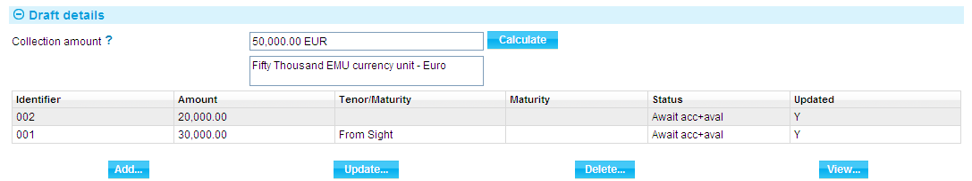

The system displays details of the selected draft.

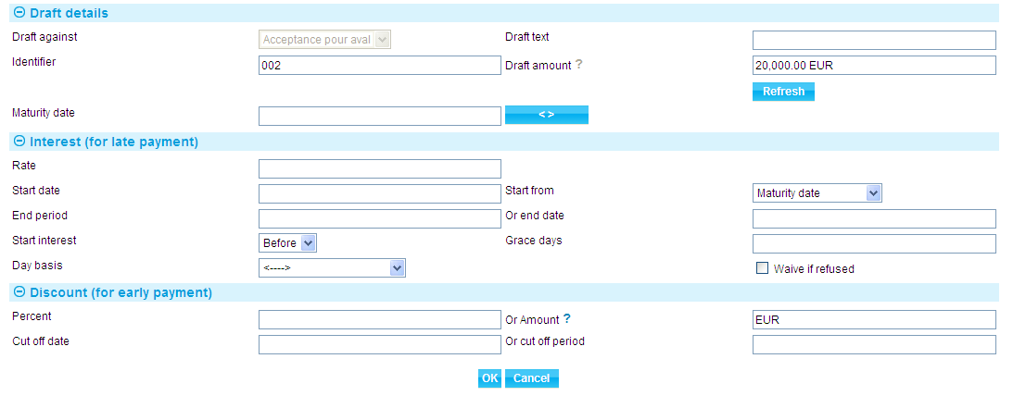

You can use the fields shown to amend details of interest rates for late payments (see page 52) and discount terms for early payments (see page 52). The information entered is the same as when first creating the collection order.

Note the following:

* You will not be able to amend drafts that have been paid in part or in full, or which have the status Returned. However, you can amend their maturity date or base date
* You will not be able to change the amount on drafts that have been partially or fully paid or have a status of Returned or Awaiting payment following Acceptance
* You can change the currency of the collection order only if there are no paid or partially paid drafts or drafts with the status Returned. If you change the currency, all drafts are changed to the new currency

## Making More Substantial Changes

The functionality of the Amend Collection event allows you to make changes to a sub-set of the information relating to a collection order. The system includes an Adjust Collection event (see page 38), which contains additional functionality to allow you to make changes to all the information for a collection order, with the exception of your bank's reference number for the collection order, and to the status of the collection order master record.

The Adjust Collection event is designed to allow you to make changes where you need to alter details but do not need to notify other parties.

Once you have initiated an Adjust Collection event, the system will prevent you from opening any other event for the collection order until the Adjust Collection event has completed. If you attempt to open an Adjust Collection event while another event for the master is in progress, the system will warn you of the fact and prompt you to abort the Adjust Collection event. Unless you are attempting to make an adjustment to allow the pre-existing event to complete, you should abort the Adjust event and wait until the pre-existing event has completed before attempting the Adjust event again. If you continue with the Adjust Collection event, then the system will prevent any further work on the pre-existing event until the Adjust Collection event has completed.

Note that, if you complete an Adjust Collection event while there is another event in progress (that is, an event pended at an Input step, or awaiting review or authorisation), then when you open that event to continue work on it, the system produces a warning advising you that the database may have changed since the event was initiated and identifying the Adjust Collection event responsible. This allows you to view the Adjust Collection event and identify what has changed.

1. This functionally is intended to allow you to correct mistakes, and should be used cautiously. If you make any changes using this functionality, you should ensure that the proper reconciliations are carried out. In particular, if you change the percentage or amount of liabilities being shared with other parties you must work out the implications and adjust the liability for the sharing parties and your own bank and then use the Manual Bookkeeping event to post those adjustments. If you make a change that might affect liability, the system issues a warning.

### Liability

The Adjust Collection event does not calculate the effect on liability for changes involving the addition or deletion of parties sharing liabilities or to the shared liability amounts and percentages. It does calculate the effect on liability of changes to the amount of the collection order or to individual drafts, or to the currency where the relative percentages of shared liability remain the same.

### Making an Adjustment to a Collection Order

In the Master Summary window select 'Adjust Collection' from the Create New Event drop-down list and click **Create**. The system opens the event at either a Log step or Input step, depending on how the Workflow orchestration controlling the event is configured. See the *Workflow Tailoring User Guide*– Trade Innovation for details.

The system will then open the window used at an Input step when creating a collection order. The system uses the same input fields for both a Log step and an Input step. Depending on how your system is configured, panes and fields available in log steps can be tailored for each data capture step. See the *SDK - Screen Tailoring Guide* – Trade Innovation for details.

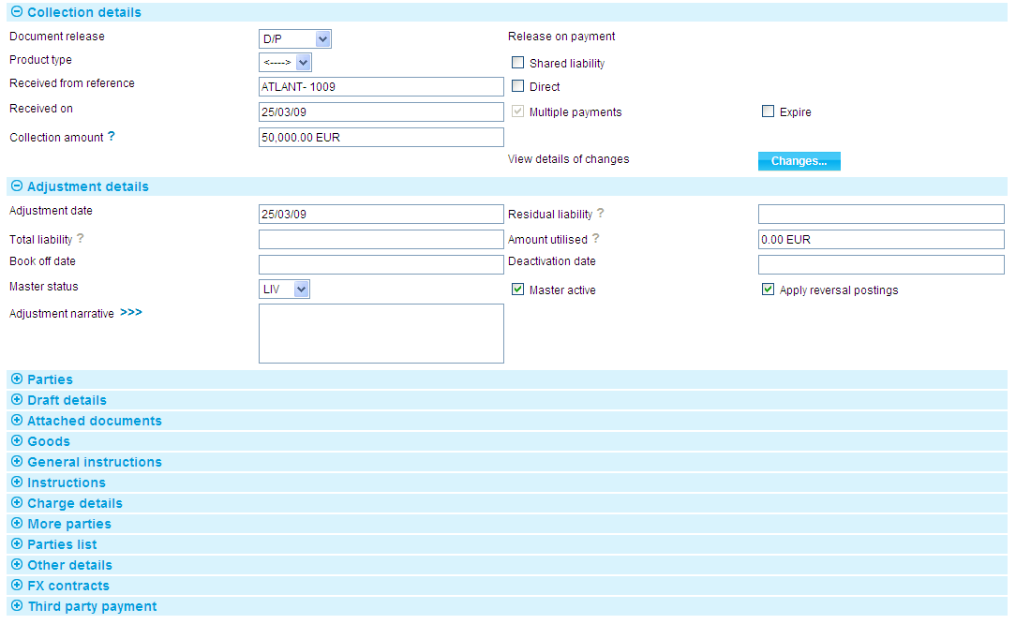

The system displays information already entered for the collection order. In addition it includes an Adjustment Details pane. The table explains what you can enter into each of the fields in this pane, and the implications of what you enter. The Changes button (see page 40) allows you to display any change made during the event.

|  |  |
| --- | --- |
| Field | What to Enter |
| Expire | Check this box if the collection order is to be expired. If you do this, the system will diarise expiry of the collection order, and subsequently book it off and delete it from the system in the usual way as part of daily batch processing once this Adjust Collection event has been released.  This facility enables you to cancel a collection order before it would normally expire. |
| Adjustment Date | The date the adjustment was made. This has no default, but is initially blank. |
| Residual Liability | The system displays the outstanding liability amount as shown on the master record, excluding the amounts of any presentations. Use this field to overwrite the figure shown on the master summary if, for any reason, the master figure is incorrect. |
| Total Liability | the system displays the outstanding liability amount as shown on the master record, including that of accepted drafts not yet paid. Use this field to overwrite the figure shown on the master summary if, for any reason, the master figure is incorrect. |
| Amount Utilised | The amount of the collection order utilised so far. |
| Amount Outstanding | This field displays the amount outstanding on the collection order, taking into account any adjustments you have made to the outstanding amount of individual drafts. You cannot alter the value displayed in this field. |
| Book Off Date | The system displays the collection order's book-off date, which you can amend. The system will then book off the collection order when the new book-off date is reached. |
| Deactivation Date | The system displays the date on which the collection order will become inactive (after its expiry date and any days grace period has elapsed). You can amend this date. |
| Master Status | The status of the collection order's master record. For a list of values see the Common Facilities User Guide – Trade Innovation. |
| Master Active | Leave this checked if the master record is to continue to be active; uncheck it to deactivate the master record. |
| Apply Reversal Postings | Leave this checked if your bank has set up reversal postings for the Adjust Collection event and wishes to apply them when the event is released. |
| Adjustment Narrative | Use this field to provide an explanation of what the adjustment consisted of and why it was carried out. |
| The system applies the following restrictions to what you can do within the Adjust event: | |
| For paid drafts | You cannot change their status or any other details. If the draft was paid incorrectly, then you must reconcile the mistake using correspondence and a manual book-keeping entry. |
| For accepted drafts awaiting payment | You can change the draft's maturity date or base date. However, if you want to change the amount of the draft, you must first change its status to Awaiting acceptance. |
| For amounts | You cannot change the amount on drafts that have been partially or fully paid or have a status of Returned or, for an accepted draft, Awaiting payment. |
| Currency | You can change the currency of the collection order only if there are no paid or partially paid drafts or drafts with the status Returned. |
| In addition | * You cannot change information for a paid draft * You cannot uncheck the Multiple Payments field whilst there is still more than one draft set up for the collection order * You cannot uncheck the Shared Liability field if details of a shared liability or amount exist for one or more other parties * If linked to a license and the overall value of drafts is increased or decreased, then a reserve (for increase) or a reinstate (for decrease - optional) against a linked license is created automatically. Validation ensures that the increase is within the amount available on the license |

## Displaying Changes

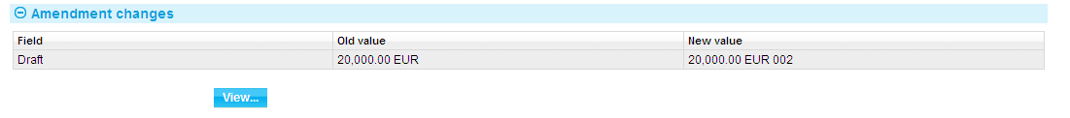

When making amendments or adjustments to a transaction the Changes button allows you - and reviewers - to list those fields that have changed within the event. It opens a window that lists those fields whose value has changed and shows for each the value before the current event and the new value resulting from the event.

For free-format narrative fields, your bank can configure the system so that it shows either the entire content of the field in the New Value column, or just a certain number of lines (defined by the system option ViewChangesLineCount) followed by the text:

>>> plus n more lines. 'View' for details.

where 33Tn33T is the number of additional lines not displayed.

Selecting that entry in the list and pressing **View** displays the entire content of the field.

This window is displayed automatically when the event is opened for review or authorisation.

1. If you work with this window open, use the Refresh button to update the display to show any changes made since you opened the window.

For fields where the value may not fit in the space available in this window (narrative fields, for example), you can select the field and click **View** to see complete details.

# Collection Orders and Payments

Payment can be made for the entire amount of a collection order or for individual drafts separately. Consequently, you may make or receive several payments for the same collection order. Also, where a collection order permits part payment, you may make or receive several part payments against a single draft.

If you are the collecting bank, you use a Payment event to enter details of payment and send them to the remitting bank. You may also use it to record details of payments received from the presenting bank.

If you are the remitting bank, you use a Payment event to record details of payments received from the collecting bank.

If your bank offers Riba-free financing an additional event - the Continue Payment event (*see page* 4) - is present to allow you to advise customers of the cost of sale and process their acceptance.

Payment details may be sent or received using a SWIFT message MT400 message.

## Payment Events and Accepted Drafts

For inward collection orders, your bank can configure the system so that a payment action is generated automatically in the diary for acceptances pour aval and acceptances where your bank holds the draft. (This is controlled by the system option AutoCreateCollectionPayEvents - see the System Tailoring User Guide – Trade Innovation.)

A separate diary action is generated for each draft.

Depending on how your bank has configured Payment events, these diarised payment actions may be used to create a Payment event automatically during overnight processing when settlement falls due; or they may need to be actioned manually before a Payment event is created from them - see the Common Facilities User Guide – Trade Innovation for instructions.

Your bank defines the step at which Payment events generated during overnight processing appear in the Work In Progress pane.

Payment events created in this way are thereafter processed in the same way as Payment events manually created, as described in this chapter.

The system permits you to create a Payment event manually to settle a draft for which a diary action has been raised (for example, to make payment earlier than the diarised action would allow). In such a case, when the Payment event is released, the system identifies the relevant diarised payment action and removes it. If payment is for less than the amount of the draft, then the diarised payment action is retained, but the amount reduced appropriately.

## Financing Transactions

If your system has the financing module implemented, then if there are any financing loans held against the collection order, you will be able to repay them from within the Payment event. See the Financing User Guide – Trade Innovation for information on repaying financing transactions.

## Finance Offers

Your bank may wish to notify customers of an offer of finance, or may need to respond to a customer’s request to finance a collection. Where this is necessary, the system uses the concept of the ‘Finance offer’.

Provisional event functionality may be used by your bank to advise its customers of costs incurred in respect of finance deals.

This is done by enabling events to be flagged as ‘Provisional’ so that an offer of finance may be sent to your bank’s customer and subsequently continued in the same event, or a continuation event.

The functionality is available for Inward and Outward, Clean and Documentary Collection products but processing varies slightly, depending on the product.

Inward collections use the Finance Inward Collection product in conjunction with the Continue Payment event. This is described in the ‘Inward Collection Orders and Riba-free financing’ section on page 43 below.

Outward collections use the Finance outward collection product in conjunction with either the Create, or Finance existing collection events. This is described in the Outward Collection orders and Finance Offers’ section on page 44 below.

### Inward Collection Orders and Riba-free Financing

The system supports Riba-free financing for inward collection orders, using the Finance Inward Collection product in conjunction with the Continue Payment event and the facility to allow events to be flagged as provisional in order to allow your bank to advise its customers of costs incurred as a result of Murabahah financing calculations and to record the customer's acceptance or rejection of those costs.

1. Your bank will need to configure the postings, charges and other release items produced on completion of a Finance Inward Collection Create event so that they are generated only if the Create event is not flagged as provisional; and so that, if the event is provisional, it results in the creation of an offer document for the customer. See the System Tailoring Guide – Trade Innovation for information on using the rules facility to achieve this.

To process an inward collection order payment with Murabahah financing, initiate a Payment event and enter details of the payment being requested in the usual way.

Set the Payment Option field to 'Finance Offer'. This creates a subsidiary Finance Inward Collection Create event. Select a product type from those flagged as supporting Islamic banking principles. Check the Provisional flag, then specify the amount of the advance in the usual way (see the Financing User Guide – Trade Innovation for detailed instructions). The system will calculate and display the Murabahah selling price using the Finance Amount Plus Interest/Profit field.

When you complete the Payment event, the subsidiary Finance Inward Collection Create event will also be released and will generate an offer document for the customer.

### If the Customer Accepts the Offer

If the customer accepts the offer, initiate a Continue Payment event and set the payment action to 'Pay with Financing'. This creates a second Finance Inward Collection Create event, with details inherited from the first. Attach the acceptance document from the customer to the event following the procedure used by your bank then uncheck the Provisional flag.

Complete the Continue Payment event to settle the payment.

### If the Customer Wishes to Negotiate a Revised Offer

If the customer does not accept the initial offer and wishes to negotiate a revised offer, initiate a Continue Payment event and set the payment action to 'Finance Offer'. This creates a second Finance Inward Collection Create event, with details inherited from the first.

Amend the details as required, keeping the Provisional flag checked.

Complete the Continue Payment event. The subsidiary Finance Inward Collection Create event will also be released and will generate an offer document for the customer showing the amended offer.

This process can be repeated as many times as necessary.

### If the Customer Rejects the Offer

If the customer rejects the offer, initiate a Continue Payment event and set the payment action to 'Pay with Financing'. Manually abort the Finance Inward Collection Create event.

### Outward Collection orders and Finance Offers

Whilst Riba-free financing utilises the concept of ‘Finance offers’, this may also be used by your bank to notify customers of an offer of finance, or to respond to a customer’s request to finance a transaction. This functionality is also available for Outward Clean and Documentary Collection orders.

1. Your bank will need to configure the postings, charges and other release items produced on completion of a Finance outward collection, Create event, or Finance existing collection event, so that they are generated only if the events are not flagged as provisional; and so that, if the event is provisional, it results in the creation of an offer document for the customer. See the System Tailoring Guide – Trade Innovation for information on using the rules facility to achieve this.

### Create Event – Finance offers

To process an outward collection order and offer financing to your bank's customer in the Create event, check the Finance requested and Provisional flags in the Collection details pane. This enables the ‘Finance offer’ button.

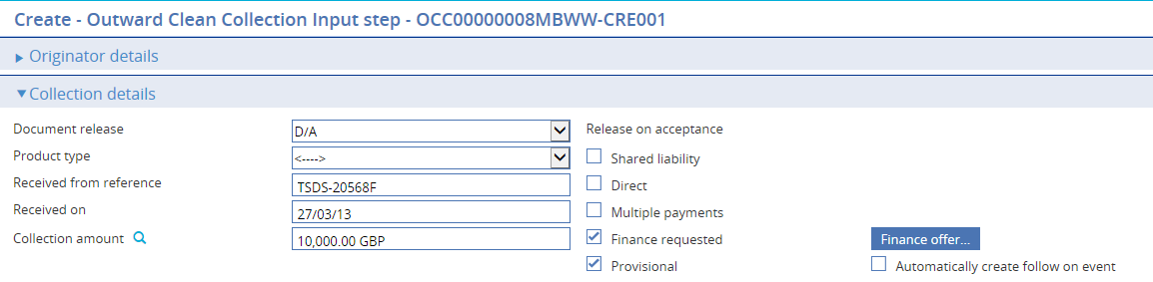

Pressing this button opens the Create – Finance outward collection screen, where you can enter financing details. Close this screen to return to the Create - Outward Collection Input screen and complete input. Finance is now offered to your bank’s customer and the event is held in a provisional state, pending a response.

### If the Customer Accepts the Offer

If the customer accepts the offer, from the Master summary screen, initiate a Continue provisional create event:

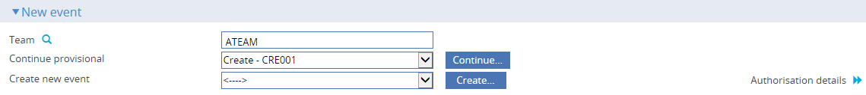

This allows you to continue processing the Create event (which includes the subsidiary finance details previously input) to conclusion. Attach the acceptance document that was received from your bank’s customer to the continue create event, following the procedure used by your bank.

Complete the event in order to remit the collection documents and complete the finance deal.

### If the Customer Wishes to Negotiate a Revised Offer

If your bank’s customer does not accept the initial offer and wishes to negotiate a revised offer, initiate a Continue Create event and check the Provisional flag. The Finance requested flag will be automatically checked and the Finance offer button enabled. This will allow you to amend the subsidiary finance event as required, keeping the Provisional flag checked.

Complete the Continue Create event. The subsidiary Finance Inward Collection Create event will also be released and will generate a revised offer document for the customer showing the amended offer.

This process can be repeated as many times as necessary.

### If the Customer Rejects the Offer

If the customer rejects the offer, initiate a Continue Create event and uncheck the Finance requested flag. Manually abort the Outward Collection, Create event.

### Finance Existing Collection Event – Finance Offers

To process an outward collection order and offer financing to your bank's customer in the Finance existing collection event, check the Finance offer required box in the Finance offer details pane:

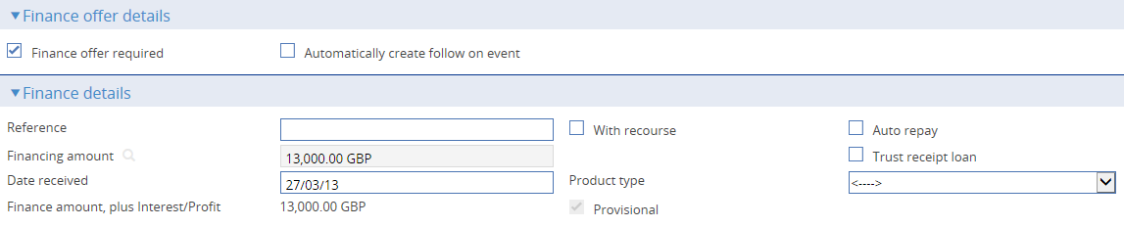

If the customer accepts the offer, from the Master summary screen, initiate a Continue Finance Existing Collection event:

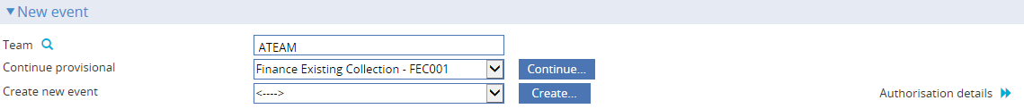

This allows you to continue processing the Finance existing collection event to conclusion. Attach the acceptance document that was received from your bank’s customer to the continue finance existing create event, following the procedure used by your bank.

Complete the event in order to remit complete the finance deal.

### If the Customer Wishes to Negotiate a Revised Offer

If your bank’s customer does not accept the initial offer and wishes to negotiate a revised offer, initiate a Continue Finance existing collection event and check the Finance offer required flag. This will allow you to amend the finance event as required, keeping the provisional flag checked.

Complete the Continue Finance existing collection event. This will generate a revised offer document for the customer showing the amended offer.

This process can be repeated as many times as necessary.

### If the Customer Rejects the Offer

If the customer rejects the offer, initiate a Finance existing collection event but do not check the Finance offer required flag. Manually abort the Finance existing collection event.

## Licenses

If a license is required for the collection order, then there will be additional processing during the processing of the payment:

* The payment amount (amount to collect) will be validated against the license and if it exceeds the license amount available, a warning message is issued and you will be asked for a new license
* Depending on how your system has been configured, a link and reservation against a license may already have been made. In this case the system will automatically drawdown the payment amount against the license. Alternatively, you may need to link to a license and then make the drawdown
* If the Latest Payment date has been entered on the license, the payment value date (and charge date) on the part payment must be before the license Latest Payment date

See the Licenses User Guide – Trade Innovation for more details.

## Entering Payment Details

To enter details of a payment, in the Master Summary window select 'Payment' from the Create New Event drop-down list and click **Create**. The system opens the event at either a Log step or Input step, depending on how the Workflow orchestration controlling the event is configured. See the *Workflow Tailoring User Guide* – Trade Innovation for details.

A Log window and an Input window both use the same input fields, and the same windows are used for all four types of collection order handled by the system.

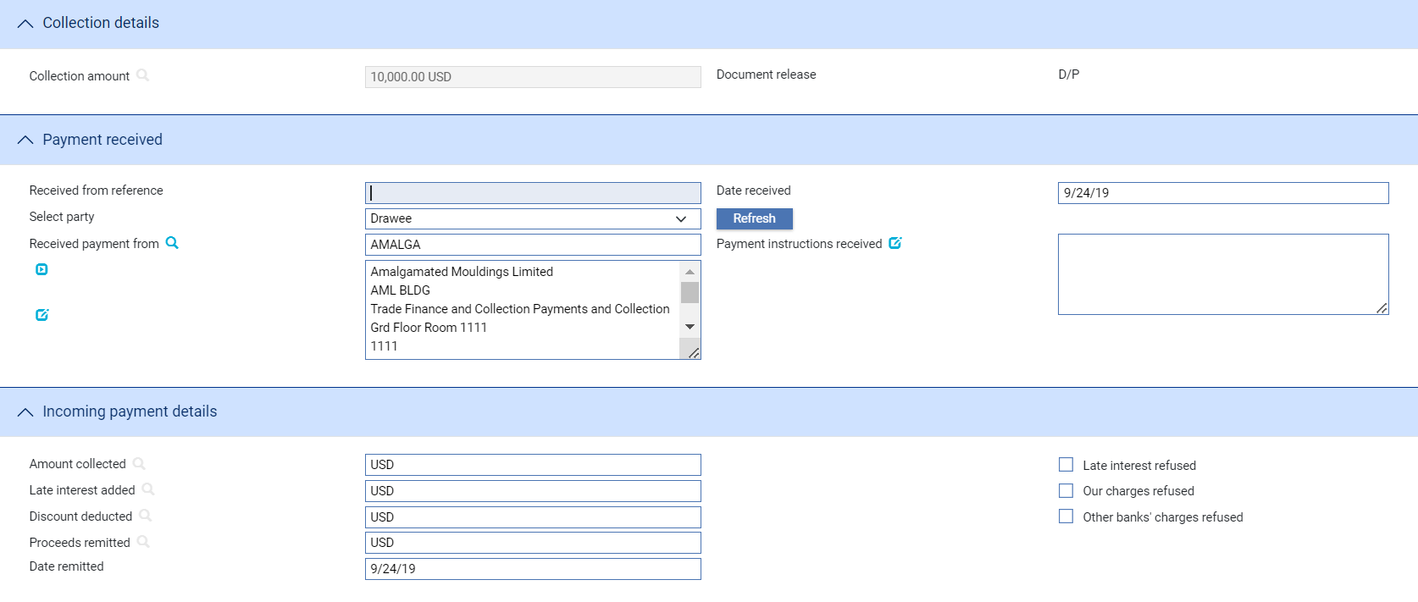

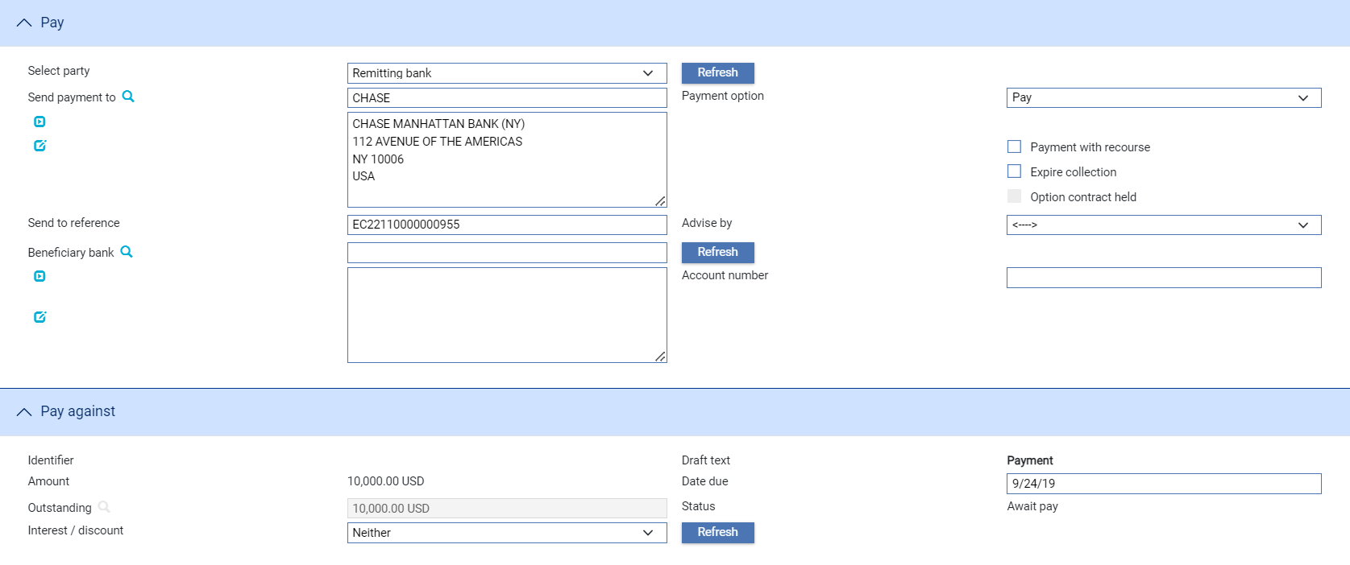

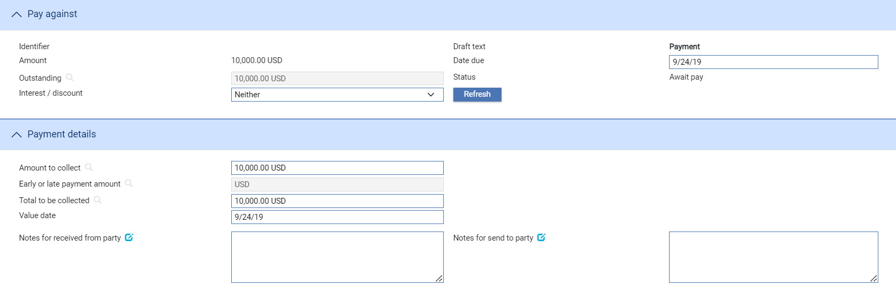

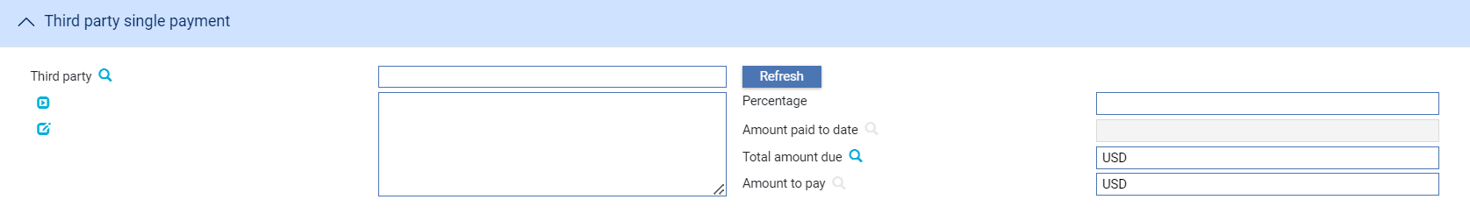

The following panes are used:

* The Collection Details Pane (see page 48)
* The Payment Received Pane (see page 49)
* The Incoming Payment Details Pane (see page 49)
* The Pay Pane (see page 50)
* The Payment Against Pane (see page 51)
* The Total Amounts Collected Pane (see page 54)
* The Third Party Payment Pane (see page 54)

If your bank has the financing functionality implemented, the Finance Repayments pane (see page 55) will also be present to allow you to repay a financing loan.

### The Collection Details Pane



The Collection Details pane displays the overall value of the collection order and the condition on which the financial or commercial documents accompanying the collection order are to be released.

### The Payment Received Pane

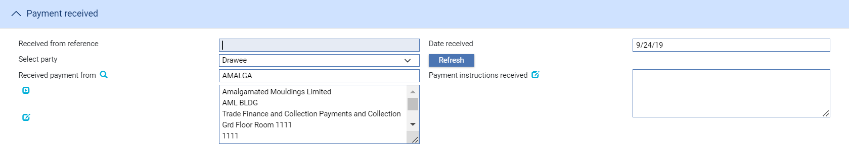

The following table explains what to enter into the fields in the Payment Received pane:

|  |  |  |
| --- | --- | --- |
|  | Field | What to Enter |
|  | Received From Reference | For a payment you have received, enter here the sender's reference for the collection order. |
|  | Date Received | For a payment you have received, enter the date you received the payment. |
|  | Received Payment From | For a payment you have received, identify the party from whom the payment was received. A drop-down list allows you to select from all parties to the collection order. The system uses the non-principal party's details as the default here. |
|  |  | If you select anything other than 'Drawee' in the Received Payment From pane, then the Sender's Charges Deducted, Charges Deducted and Charges Added fields are displayed, allowing you to record details of these charges. |
|  | Payment Instructions Received | Any free-format instructions received with the payment from the sender. |

### The Incoming Payment Details Pane

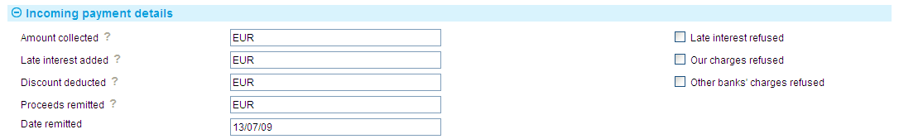

The following table explains what to enter into the fields in the Incoming Payment Details pane:

|  | Field | What to Enter |
| --- | --- | --- |
|  | Amount Collected | The value of the payment being made. The value you enter here may represent a single collection order payment, several payments, or a part payment, if the collection order permits part payments to be made. |
|  | Late Interest Added | The value of any late interest that has been received. |
|  | Discount Deducted | The value of any discount amount due for prompt payment. |
|  | Proceeds Remitted | The total value of the payment, allowing for interest, discount and charges. This should be a total figure of all the figures preceding it. |
|  | Date Remitted | The date the payment is to be debited from the account of the sender. This defaults to today's date. |
|  | Late Interest Refused | Check this box if the drawee has refused to pay late interest charges. The system will issue a warning if you do this for a collection order that does not permit late interest charges to be waived if refused. |
|  | Our Charges Refused | Check this box if the drawee has refused to pay your bank's charges. |
|  | Other Bank's Charges Refused | Check this box if the drawee has refused to pay another bank's charges. Use the free format text field in the Payment Instructions Received pane to indicate whose charges have been refused. |

### The Pay Pane

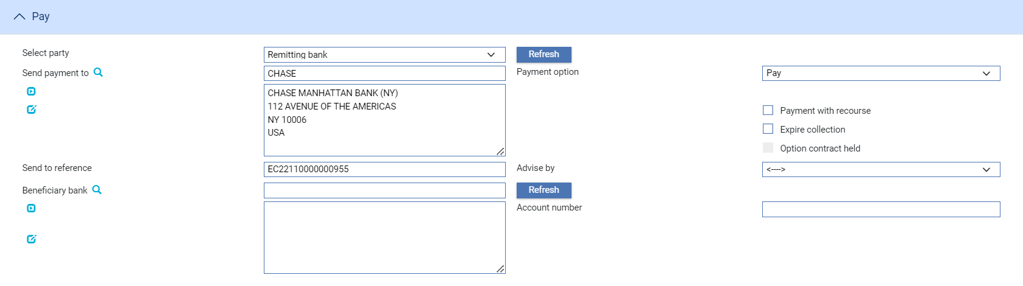

The drop-down field allows you to select the payment action. Select one of the following:

* Pay, to process a simple payment
* Pay with Financing, to process a payment with financing. The system displays a Finance button, which opens a window in which you can enter details of the financing transaction. See the Financing User Guide – Trade Innovation
* Finance Offer, present for inward collection orders to allow you to process payment with Riba-free financing (see page 43). Click **Finance** to open a window that allows you to enter details of the financing offer

The following table explains what to enter into the rest of the fields in the Pay pane:

|  | Field | What to Enter |
| --- | --- | --- |
|  | Send Payment To | If you are sending a payment, identify the party to whom payment details are to be sent. The Select Party drop-down list allows you to select from all parties to the collection order by party role. The system uses the principal party’s details as the default value here. |
|  | Send To Reference | The Send To party’s reference for the transaction. |
|  | Advise By | The method to be used to transmit the documents to the Send To party. |
|  | Beneficiary Bank | You may use this field to enter another bank to which payment may be made (that is, another beneficiary institution). This is used by the system to automatically enter the beneficiary institution in field 58 of an MT400. |
|  | Notes for Received From Party | Any notes for the party to be debited. |
|  | Payment With Recourse | Check this box if the payment is with recourse. |
|  | Expire Collection | If this is the final payment for the collection order, you can check this box in order to diarise expiry of the collection order’s master record.  This can also be used to discharge a collection order. |
|  | Option Contract Held | Check this field if foreign exchange option contracts are held against the collection order. |
|  | Account No | The number of the account to be used at the beneficiary bank. |
|  | Notes for Send To Party | Any notes for the bank to which you are sending the payment details. |

### The Payment Against Pane

If there is a single draft, the Payment Against pane allows you to enter details of a single payment.

If there is more than one draft, the Pay Against pane lists each of these drafts.

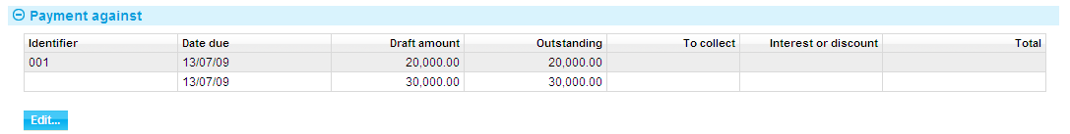

You can select a draft and click **Edit** to display a window that allows you to enter details of payment against that draft.

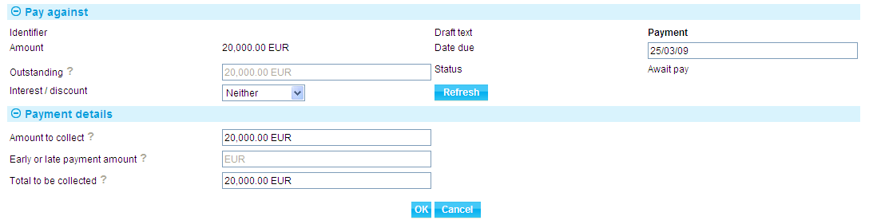

The details entered are the same as for a single draft.

For an inward collection order, depending on how your system is configured, the Margin Amount field may be present. If margin deposit details have been entered against the collection order, you can use this field to enter how much of the margin deposit you wish to use against this payment. (If no margin deposit details have been entered, the fields are disabled.)

If you have already entered details of payments to be made to a third party these are displayed in the Third Party Payment pane and you can overwrite them. Alternatively, you can use these fields to enter details of payments to be made to a third party at this point in the life-cycle of the collection order.

If the draft has attracted a prompt payment discount or a late interest payment, you can display additional fields that allow you to enter details of:

A discount for early payment (see page 53)

Interest for late payment (see page 53)

The following table on the lists each of the fields used to enter payment against a draft explains what it to enter into them:

|  | Field | What it Shows |
| --- | --- | --- |
|  | Identifier | The identifier used to differentiate this draft from others associated with the collection order. |
|  | Draft Text | A description of the draft. |
|  | Amount | The amount of the draft as originally defined when the collection order was created, followed by the code of the currency of the collection order. |
|  | Date Due | The date the payment is due. If the draft has been accepted, then the system will display the date payment is due, as set during acceptance. If this field is blank, then you must enter the date the payment is due as part of the payment details. |
|  | Outstanding | The amount of the draft still outstanding. |
|  | Status | The status of the payment. See the *C*ommon Facilities User Guide – Trade Innovation for a list of statuses. |
|  | Interest/Discount | If the payment has attracted a discount for early payment or interest for late payment, select the appropriate value here and click **Refresh**.  The system displays an additional pane, into which you can enter details of the discount (see page 52) or interest (see page 52) to apply. |

Where there is more than one draft, the Total to Collect field shows a total for the To Collect column, and the Total Interest/Discount field a total for the Interest and Discount columns combined. The Grand Total shows the total amount due to the principal party, excluding any charges to be deducted. These fields are automatically updated as you allocate amounts against payments, and you cannot change them. You can enter the Value Date to be used when settling the payment. For multiple payments, these fields appear in a separate pane.

### Discount for Early Payment

If you select 'Early Discount' in the Interest/Discount field and then click **Refresh**, the system displays the additional fields showing details of any discount due.

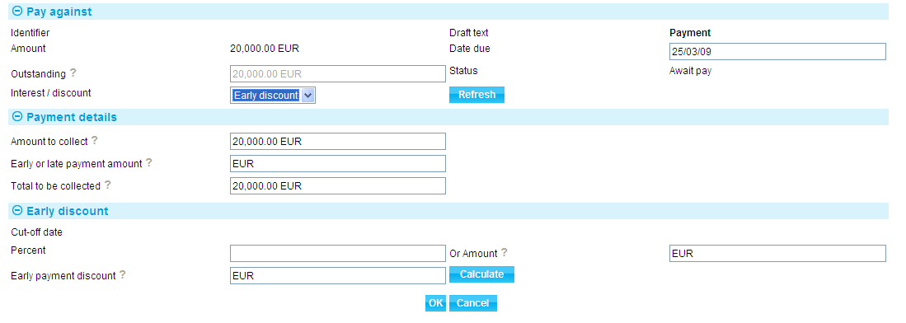

The system displays the cut-off date for discount on this payment entered when the collection order was created, and any discount due on the payment in the Early Payment Discount field and the field below the Interest/Discount pane.

You can enter the discount either as a percentage or as an amount.

To enter the discount as a percentage of the payment amount, enter the percentage figure into the Percent field, then click **Calculate**. The system calculates the discount amount and displays the resulting figure in the Early Payment Discount field, and also in the field below the Interest/Discount field, where it is used to overwrite any existing discount amount.

To enter the discount as an amount, enter the discount amount in the currency of the collection order, then click **Calculate**. The system again displays the resulting figure in the Early Payment Discount field, and also in the field below the Interest/Discount field, where it is used to overwrite any existing discount amount.

### Interest for Late Payments

If you select ' Late Interest' in the Interest/Discount field, the system displays additional fields showing the late interest details set up for the payment.

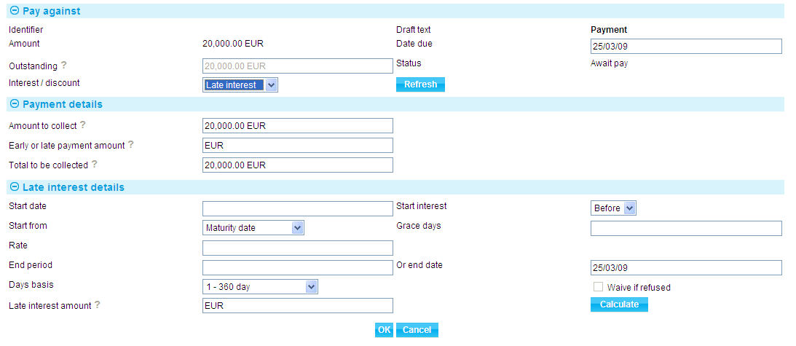

You can enter or amend the late interest to be charged in one of two ways:

* By entering the late interest amount into the Late Interest Amount field. If you do this, do not amend the values in any other fields in this window
* By amending any of the other details shown in this window, then pressing **Calculate**. If you do this, the system automatically calculates the late interest due according to the new values you have entered, and displays the amount in the Late Interest Amount field, and also in the field below the Interest/Discount field, where it is used to overwrite any existing interest amount

### The Total Amounts Collected Pane

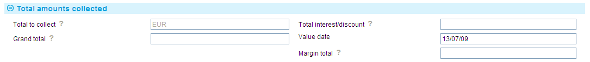

The following table explains what to enter into the fields in the Payment Details pane:

|  |  |  |
| --- | --- | --- |
|  | Field | What to Enter |
|  | Total to Collect | The system calculates and displays the total amount to be collected. |
|  | Total Interest/Discount | The early discount amount or the interest due amount, as appropriate. |
|  | Grand Total | The system calculates and displays the total amount to be collected, taking in to account any early discount amount or interest due amount. |
|  | Value Date | The date the payment is due. If the draft has been accepted, then the system will display the date payment is due, as set during acceptance. If this field is blank, then you must enter the date the payment is due as part of the payment details. |
|  | Margin Total | Present for inward collection orders, depending on how your system is configured. If margin deposit details have been entered against the collection order, you can use this field to enter how much of the margin deposit you wish to use against this payment. (If no margin deposit details have been entered, the field is disabled.) |

### The Third Party Payment Pane

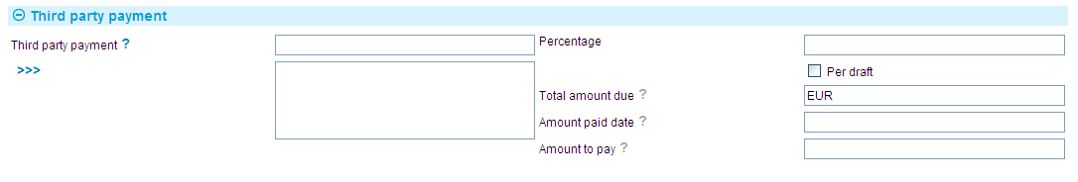

The following table explains what to enter into the fields in the Third Party Payment pane:

|  |  |
| --- | --- |
| Field | What it Shows |
| Third Party | If a payment is being made to a third party, use the fields in the Third Party Payment pane to identify the party to receive the payment and the amount to be paid. If you have already entered this information then the system displays information in these fields, which you can overwrite.  The first field in the pane identifies the party to whom the payment is to be made. |
| Percentage | You can define the amount to be paid to the third party either as a percentage, or as an actual amount in the Total Amount Due field. |
| Amount Paid To Date | Displays the amount paid to the third party so far against the collection order. |
| Total Amount Due | Displays the total amount due to the third party for the entire collection order. |
| Amount to Pay | The system calculates the amount due to the third party and displays it in this field. You can override the figure as required. |

### The Finance Repayments Pane

If your bank has the financing functionality implemented, you will be able to repay a financing loan from within a Payment event using the Finance Repayments pane.

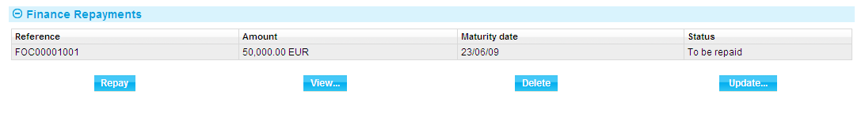

This pane lists details of any financing loans entered against the collection order. You can highlight the loan and then click **View** to view details of that loan.

To repay a loan, highlight it, then click **Repay**.

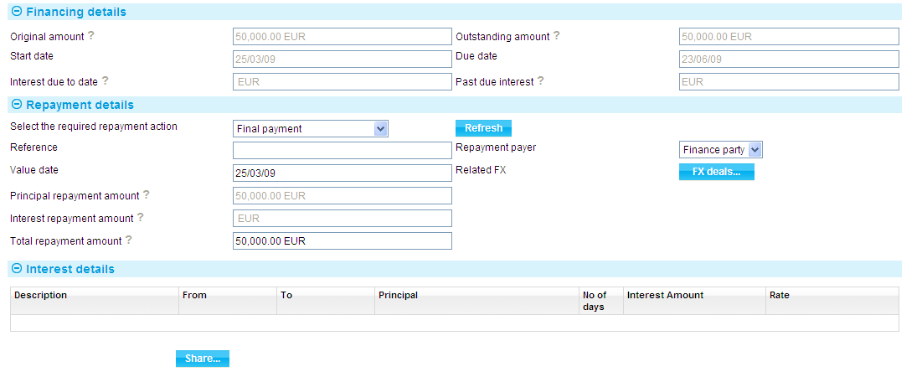

In the window that is displayed, enter details of the repayment; see the Financing User Guide – Trade Innovation. When you close this window, the repayment details are shown in the Payment event.

You can use the View, Update, and Delete buttons to view, amend or delete the repayment details.

If the transaction has more than one loan held against it, you can repay one or more of them within the same event, selecting each in turn and allocating funds to them, as described in the Financing User Guide – Trade Innovation.

# Loans against Outward Collection Orders

The system permits you to enter details of a loan to the drawer against an outward order only, either during the Create event Input step, or after the collection order has been created using an Advance event (see page 56). You can enter a single loan only against each collection order, for up to 100% of the value of the collection order.

You can enter a loan in any currency supported by your system. You can define either a discounted loan or a loan with interest at maturity. The system supports fixed rate interest only on loans against collection orders. Once payment against the collection order is received, then the proceeds can be used to repay the outstanding loan amount and any interest due.

Following explains how to record a loan made to a drawer against a collection order, and then repay it. See Chapter 2 for instructions on entering loan details during the Create event and Chapter 6 for instructions on paying a loan as part of a Payment event.

1. The functionality described in this chapter is used for systems where the financing module is not implemented. It is also used to handle loans entered on your system prior to the implementation of the financing module. If your system has the financing module implemented see the Financing User Guide – Trade Innovation for information on entering and repaying loans against collection orders.

## Loan Repayment

Loan repayments can be made as a collection order is paid, either in part or in full. Repayments can be entered in two ways:

* As part of the Payment event from within the Settlements window. The Settlements window will include a Repayments button for this purpose if there is an outstanding loan against the collection order
* Using a separate event - the Repay Advance event

The system permits full and partial repayments. Where a loan has interest paid at maturity, the system allows you to record partial payments with or without interim interest payments as funds are received.

Where the loan has interest paid at inception, if the repayment is received after the original discount maturity date an additional charge may need to be entered. The system issues a warning that extra interest may apply. Similarly, a warning is issued where a repayment is made before the maturity date of the deal and a refund of discount may need to be entered using a Manual Bookkeeping event.

If the loan was set up in a currency different from the collection currency, then you will need to enter a foreign exchange deal to convert the payment amount to the repayment amount. You can do this via the Settlement Details window - see the Common Facilities User Guide – Trade Innovation.

## Entering Loan Details after Creating the Collection Order

To enter details of a loan against a collection order after the collection order details have been entered, in the Master Summary window select 'Advance' from the Create New Event drop-down list. The system opens the event at either at a Log step or Input step. Depending on how your system is configured, panes and fields available in log steps can be tailored for each data capture step. See the *SDK - Screen Tailoring Guide* – Trade Innovation for details.

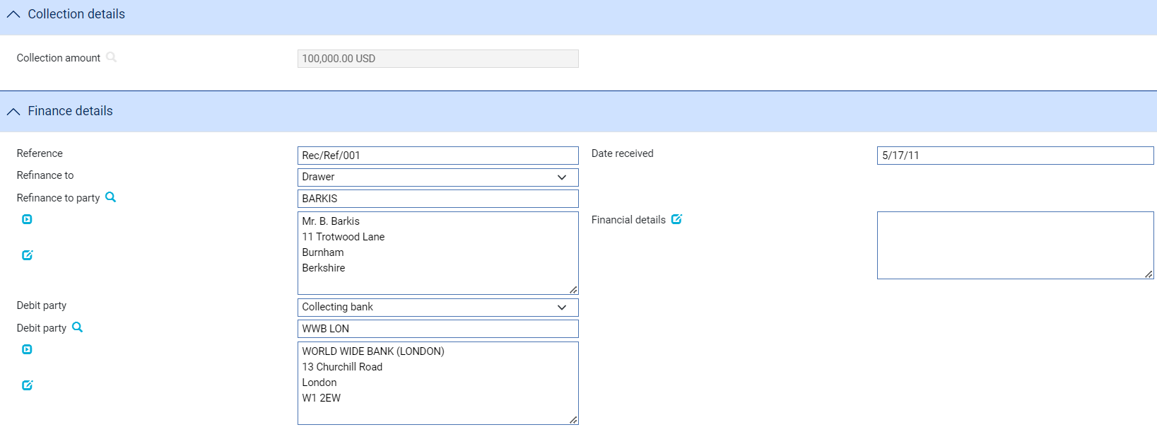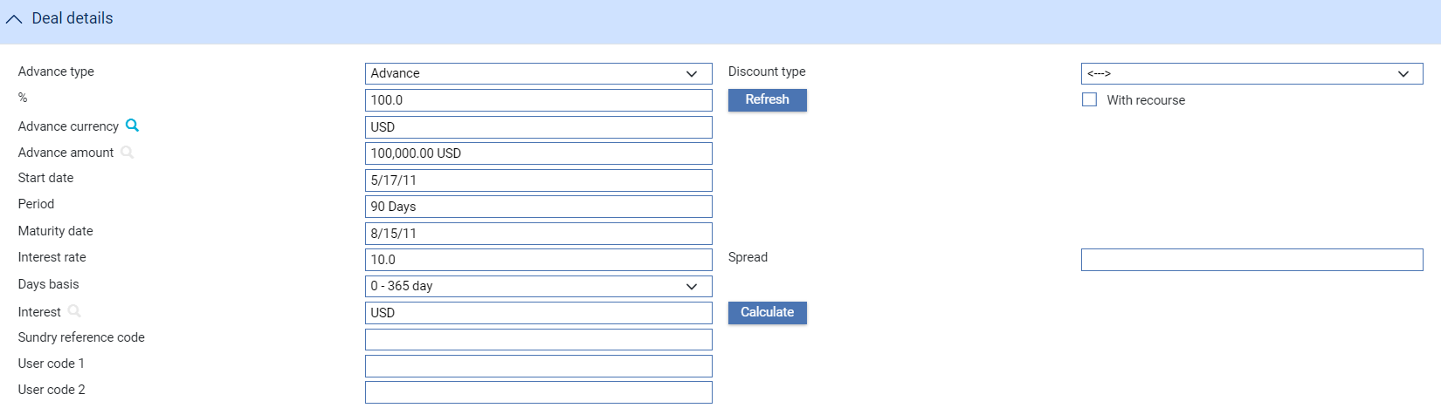

The following table explains what to enter into the fields displayed:

|  | Field | What to Enter |
| --- | --- | --- |
|  | Collection Amount | The system displays the total amount and currency of the collection order against which the loan is being made. |
|  | Reference | The drawer's reference number for the request for finance. |
|  | Date Received | The date the request was received. This defaults to today's date. |
|  | Refinance To Party | The party to whom the loan is being made. The system uses the principal party as default. |
|  | Debit Party | The debit party, should discount be payable by the drawee or the drawee's bank. The system uses as a default the non-principal party. |
|  | Financial Details | Any notes to the recipient of the loan. |
|  | Advance Type | Select the type of deal and click **Refresh**. If you select 'Advance', the system displays an additional field, into which you should enter the percentage of the collection order to be advanced.  If you select 'Negotiation', then the advance will be for 100% of the collection order value. |
|  | Discount Type | Select 'Discount' if interest is to be paid at inception. Select 'Discount to Yield' if the discount to yield formula is to be used to calculate the discount instead of the standard discount formula.  When you click **Refresh**, the system displays additional fields for you to enter the discount amount and net amount. Use the Discount Paid By field to define who will pay the discount interest amount on the loan. |
|  | % | If you have selected 'Advance' in the Advance Type field, enter the percentage of the collection order amount to be advanced as a loan.  If you have selected 'Negotiation' in the Advance Type field, this field it set to 100%. |
|  | With Recourse | Check this box if the loan is with recourse. |
|  | Advance Currency | Define the currency of the loan, if different from the currency of the collection order.  If you enter a currency here that is different from the collection order currency, the system displays additional fields which you can use to identify the exchange rate to be used to convert the loan amount from the collection currency. You can enter either an exchange rate code, or an actual rate.  When you have selected an exchange rate, the system calculates and displays the converted amount in the Advance Amount field. |
|  | Advance Amount | If you have selected 'Advance' in the Advance Type field, enter here the amount that is to be advanced. The % field will be automatically recalculated. If you have selected 'Negotiation', this will be the entire amount of the collection order. |
|  | Start Date | The start date of the loan. |
|  | Period | The deal period for the loan. The system automatically calculates the maturity date. |
|  | Maturity Date | The maturity date, if known. Typically, this will be left blank to allow the deal to proceed as an open date deal. If you have checked the Discount box, then you must specify a maturity date either directly or by using the Period fields. |
|  | Rate | The overall rate at which interest or discount is to be calculated (including the spread). |
|  | Spread | The spread rate that has been added to the interest rate. This is used for reporting purposes only. |
|  | Days Basis | The days basis to be used to calculate the interest. A list of values is given in the Common Facilities User Guide – Trade Innovation. |
|  | User Codes | You may use this field to enter a value for analysis purposes. Your bank will have devised its own system for using this field. |

## Repayment via the Settlements Window

From within the Payment event click **ReleaseItems|Settlements**. This displays the Settlement Details window, which will have a Repayment button on it.

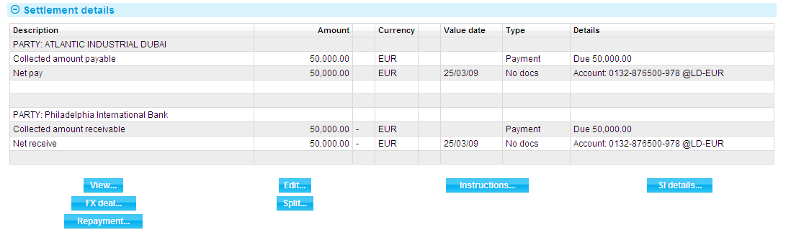

1. For more information on the Settlement Details window, see the Common Facilities User Guide – Trade Innovation.

Select the appropriate entry in this window and click **Repayment**.

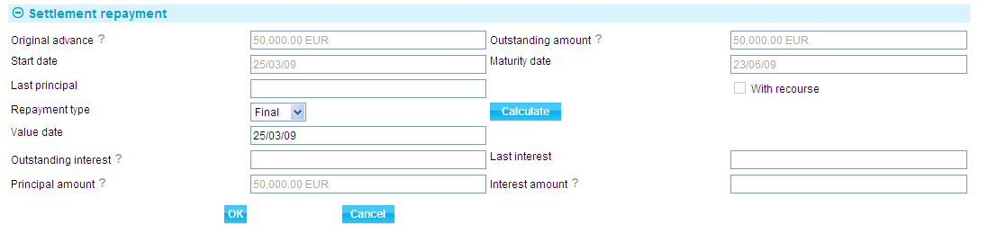

For a discounted loan, the fields pertaining to interest are not present.

The table at the end of this section explains what to enter into the fields in this window.

To repay the loan in full, select 'Final' in the Repayment Type field. The system displays the full amount of the loan still outstanding in the Principal Amount field, and for non-discount loans the full amount of any interest still due in the Interest Amount field. You cannot overtype these figures.

To record a partial repayment, select 'Partial' in the Repayment Type field, then enter the amount of the principal being repaid in the Principal Amount field and for non-discount loans any interest being repaid in the Interest amount field.

The information entered in this window is processed as part of the Payment event.

|  |  |  |
| --- | --- | --- |
|  | Field | What to Enter |
|  | Original Advance | The amount and currency of the original loan, excluding any part payments that may have been made. |
|  | Outstanding Amount | The amount of the loan still outstanding, and the code of the currency of the amount. |
|  | Start Date | Displays the date on which the loan advance was made. |
|  | Maturity Date | Displays the date on which the loan is due to be repaid in full. |
|  | Outstanding Interest | For non-discount loans, this field shows any outstanding interest overdue from previous payments, and the code of the currency of the interest. If the repayment is against a discounted loan, then the system will not display the interest amount field as interest has been taken at inception. |
|  | Last Interest | For non-discount loans, this field shows the date on which interest was last paid. This is displayed for information only. |
|  | Last Principal | Displays the date on which the last repayment of principal was made. This is displayed for information only. |
|  | Repayment | Indicate whether the repayment is a partial payment or a final repayment of the balance of the loan. |
|  | Value Date | The date on which the repayment is to be made. The value date cannot be before the last processing date if interest is being paid. If principal only is being paid, the value date cannot be before the last interest payment date. |
|  | Principal Amount | The amount being repaid. If you have selected 'Final' in the Repayment field, then the system will display the balance of the loan in this field, and you will not be able to overtype it. If you have selected 'Partial', then enter the amount of the part payment in this field. |
|  | Interest Amount | If you have selected 'Final' in the Repayment field, then the system will display the balance of the interest still outstanding in this field, and you will not be able to overtype it. If you have selected 'Partial', then enter the amount of interest being paid with this part payment. |
|  | With Recourse | Shows whether the original advance was with recourse or not. |

You can subsequently amend the repayment details by selecting the loan repayment in the Settlements window and then pressing **Edit**. The system displays details of the repayment, which you can overtype.

## Repayment Using the Repay Advance Event

In the Master Summary window select 'Repay Advance' from the Create New Event drop-down list. The system opens the event either at a Log step or Input step. Depending on how your system is configured, panes and fields available in log steps can be tailored for each data capture step. See the *SDK - Screen Tailoring Guide* – Trade Innovation for details.

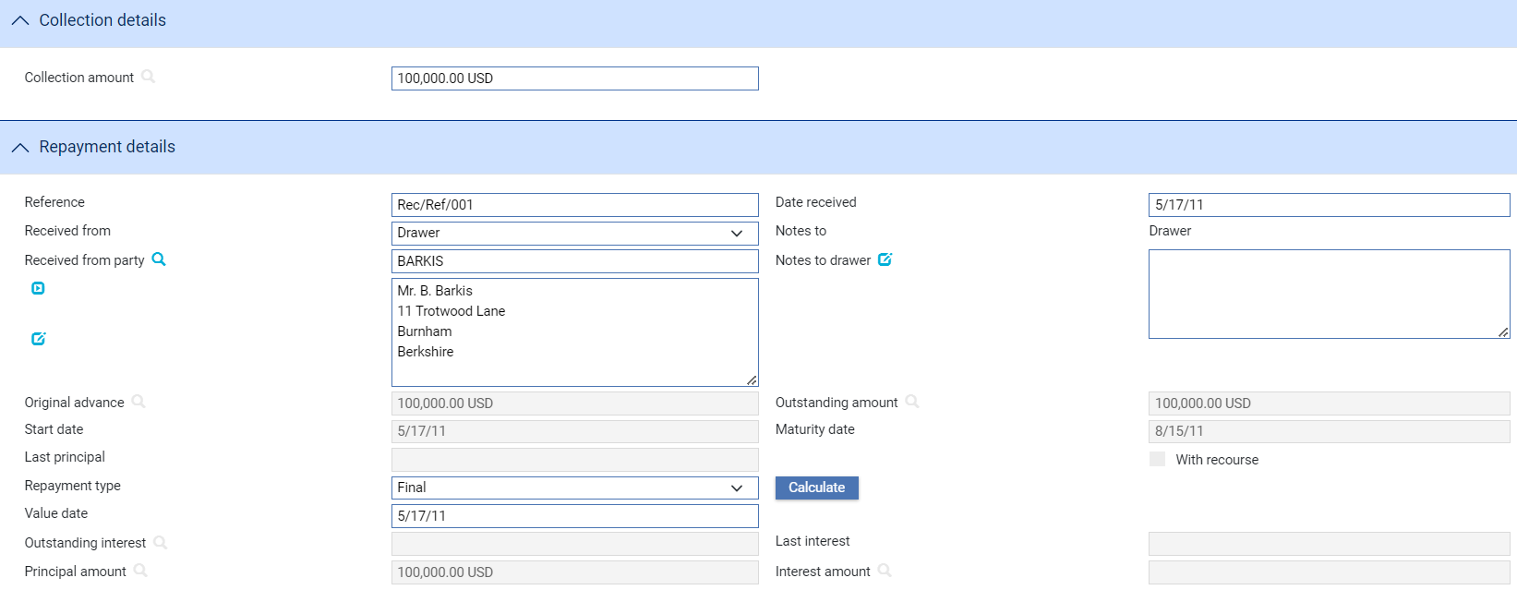

The window displayed shows details of the loan. For a discounted loan, fields pertaining to interest are not present.

To repay the loan in full, select 'Final' in the Repayment Type field. The system displays the full amount of the loan still owing in the Principal Amount field, and for non-discount loans the full amount of any interest still due in the Interest Amount field. You cannot overtype these figures. The system repays the outstanding amount using the value date entered for the loan repayment.

To enter a partial repayment, select 'Partial' in the Repayment Type field, then enter the amount of the principal being repaid in the Principal Amount field and for non-discount loans any interest being repaid in the Interest Amount field. The balance of the loan will be reduced by the amount entered for the value date, and interest will be posted for the loan for the value date entered.

The following table explains what to enter into each of the fields in this window:

|  | Field | What to Enter |
| --- | --- | --- |
|  | Reference | The reference of the party making the payment. |
|  | Date Received | The date on which the payment was received. The system uses today's date as the default. |
|  | Collection Amount | Displays the amount and currency of the collection order for information only. |
|  | Received From | The party making the repayment. The system displays the details of the party to whom the loan was made as a default. |
|  | Notes to Drawer | Any notes to the drawer. |
|  | Original Advance | Displays the amount and currency of the original loan, excluding any part payments that may have been made. |
|  | Outstanding Amount | Displays the amount of the loan still outstanding, and the code of the currency of the amount. |
|  | Start Date | Displays the date on which the loan advance was made. |
|  | Maturity Date | Displays the date on which the loan is due to be repaid in full. |
|  | Outstanding Interest | For non-discount loans, this field shows any outstanding interest overdue from previous payments, and the code of the currency of the interest. If the repayment is against a discounted loan, then the system will not display the interest amount field as interest has been taken at inception. |
|  | Last Interest | For non-discount loans, this field shows the date on which interest was last paid. This is displayed for information only. |
|  | Last Principal | Displays the date on which the last repayment of principal was made. This is displayed for information only. |
|  | Repayment | Indicate whether the repayment is a partial payment or a final repayment of the balance of the loan. |
|  | Value Date | The date on which the repayment is to be made. The value date cannot be before the last processing date if interest is being paid. If principal only is being paid, the value date cannot be before the last interest payment date. |
|  | Principal Amount | The amount being repaid. If you have selected 'Final' in the Repayment field, then the system will display the balance of the loan in this field, and you will not be able to overtype it. If you have selected 'Partial', then enter the amount of the part payment in this field. |
|  | Interest Amount | If you have selected 'Final' in the Repayment field, then the system will display the balance of the interest still outstanding in this field, and you will not be able to overtype it. If you have selected 'Partial', then enter the amount of interest being paid with this part payment. |
|  | With Recourse | Displays whether the original advance was with recourse or not. |

# Discounting Accepted Drafts

This chapter explains how to use the system to discount drafts once they have been accepted.

For drafts against acceptance, once a draft has been accepted, and provided the accepted draft is held by the bank, the system allows you to make early payment for the draft by discounting the accepted payment. The system permits you to make several early payments against the same discounted draft.

Typically, as remitting bank, you use the functionality described in this chapter to make early payment of an accepted draft to the drawer for an outward collection order.

1. The functionality described in this chapter is used by systems where the financing module is not implemented. If your system has the financing module implemented see the Financing User Guide – Trade Innovation for information on discounting accepted drafts.

## Entering Details of the Discounted Acceptance

To discount an accepted payment, in the Master Summary window select 'Discount Acceptance' from the Create New Event drop-down list and click **Create**. The system opens the event at either at a Log step or Input step. Depending on how your system is configured, panes and fields available in log steps can be tailored for each data capture step. See the *SDK - Screen Tailoring Guide* – Trade Innovation for details.

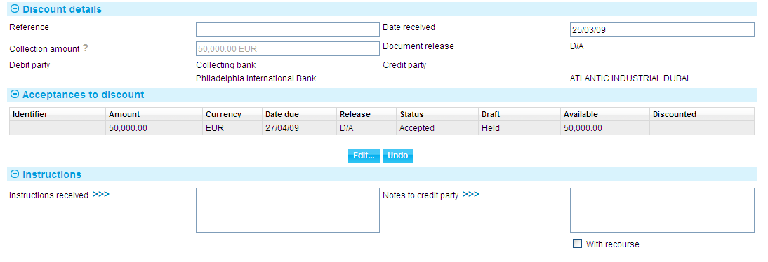

The window displayed shows a sender's reference for the collection order, the date it was received, the collection amount and currency, the conditions for release of the collection order, the debit party and the credit party. The Acceptances to Discount pane lists all the drafts associated with the collection order that have been accepted but not yet paid.

In the Acceptances to Discount pane, information is provided under the following headings:

| Heading | What it Shows |
| --- | --- |
| Identifier | The draft identifier. |
| Amount/Currency | The amount and currency of the draft. |
| Date Due | The maturity date for the draft. |
| Release | Whether the financial or commercial documents accompanying the draft are to be released against payment, acceptance, or acceptance pour aval. |
| Status | The status of the draft. A list of values is given in the Common Facilities User Guide– Trade Innovation.  The system will allow you to discount drafts only if they have a status of Accepted. |
| Draft | Indicates whether the accepted draft is being held by your bank, or has been returned to the drawer. The system will allow you to discount drafts only if they are being held by a bank involved in the collection. |
| Available | The amount of the draft against which early payments can be made. This excludes any loans that have previously been made against the draft or amounts due to third parties. |
| Discounted | Shows the value of any early payments your bank has made against the draft. |

You can use the Instructions Received field to enter any instructions you have received from the credit party regarding the discounting of the accepted draft or drafts, and the Notes to Credit Party field to enter any narrative for the credit party. Click once on the With Recourse box so that it is checked if the payment is being made with recourse.

To discount a draft, select the draft. Provided that the draft has been accepted and the accepted draft is being held by a bank involved in the transaction, the Edit button is enabled. When you click **Edit**, the system displays details of the selected draft.

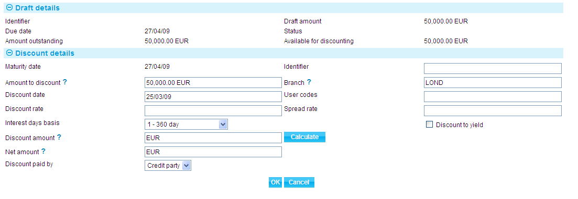

The Draft Details pane displays the draft's identifier and status, the value of the draft, the amount still to be paid, the date the draft is due to be paid, and the amount available for discounting.

The table at the end of this section explains what to enter into each of the fields in this window to discount a draft. Click **Calculate** after entering information for the system to calculate and redisplay the discount values.

The Undo button in the main Input window allows you remove details of any early payment (discount details) you have recorded against a draft in this event.

|  |  |  |
| --- | --- | --- |
|  | Field | What to Enter |
|  | Amount to Discount | The amount to be discounted. |
|  | Maturity Date | Displays the maturity date for the draft. |
|  | Discount Date | The date the discounted payment is to be made. The system uses today's date as a default. |
|  | Discount Rate | If you wish to calculate the discount as a percentage of the early payment, enter the overall rate at which discount is to be calculated (including the spread). The system uses this figure to calculate the discount, which it then displays in the Discount field.  Alternatively, you can enter the discount as an amount in the discount field. |
|  | Interest Days Basis | Select the days basis to be used to calculate the interest. A list of values is given in the Common Facilities User Guide – Trade Innovation. |
|  | Discount Amount | The amount of the discount. If you enter a value into the Discount Rate field, the system calculates the discount and displays it in this field, where you can overwrite it. Alternatively, you can enter the discount value directly into this field and the rate will be automatically recalculated. |
|  | Net Amount | The total value of the early payment, considering any discount due. |
|  | Identifier | You can enter an additional reference to identify this discount. |
|  | Branch | The branch that owns the discount deal. |
|  | User Codes | You may use this field to enter a value for analysis purposes. Your bank will have devised its own system for using this field. |
|  | Spread Rate | The spread rate that has been added to the interest rate. This is used for reporting purposes only. |
|  | Discount Paid By | Indicate which party is to pay the discount on the early payment. |
|  | Discount to Yield | Check this box if the discount to yield formula is to be used to calculate the discount instead of the standard discount formula. |